Task Overview
Topic: Task Overview
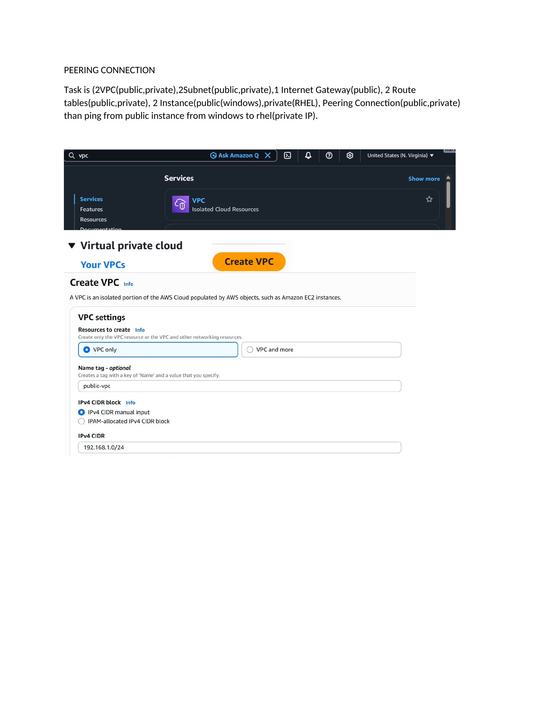
What I did: The task is to build two VPCs with public/private subnets, an Internet Gateway, route tables, Windows and RHEL instances, then configure VPC peering for private communication.

Create Public VPC
Topic: Create Public VPC
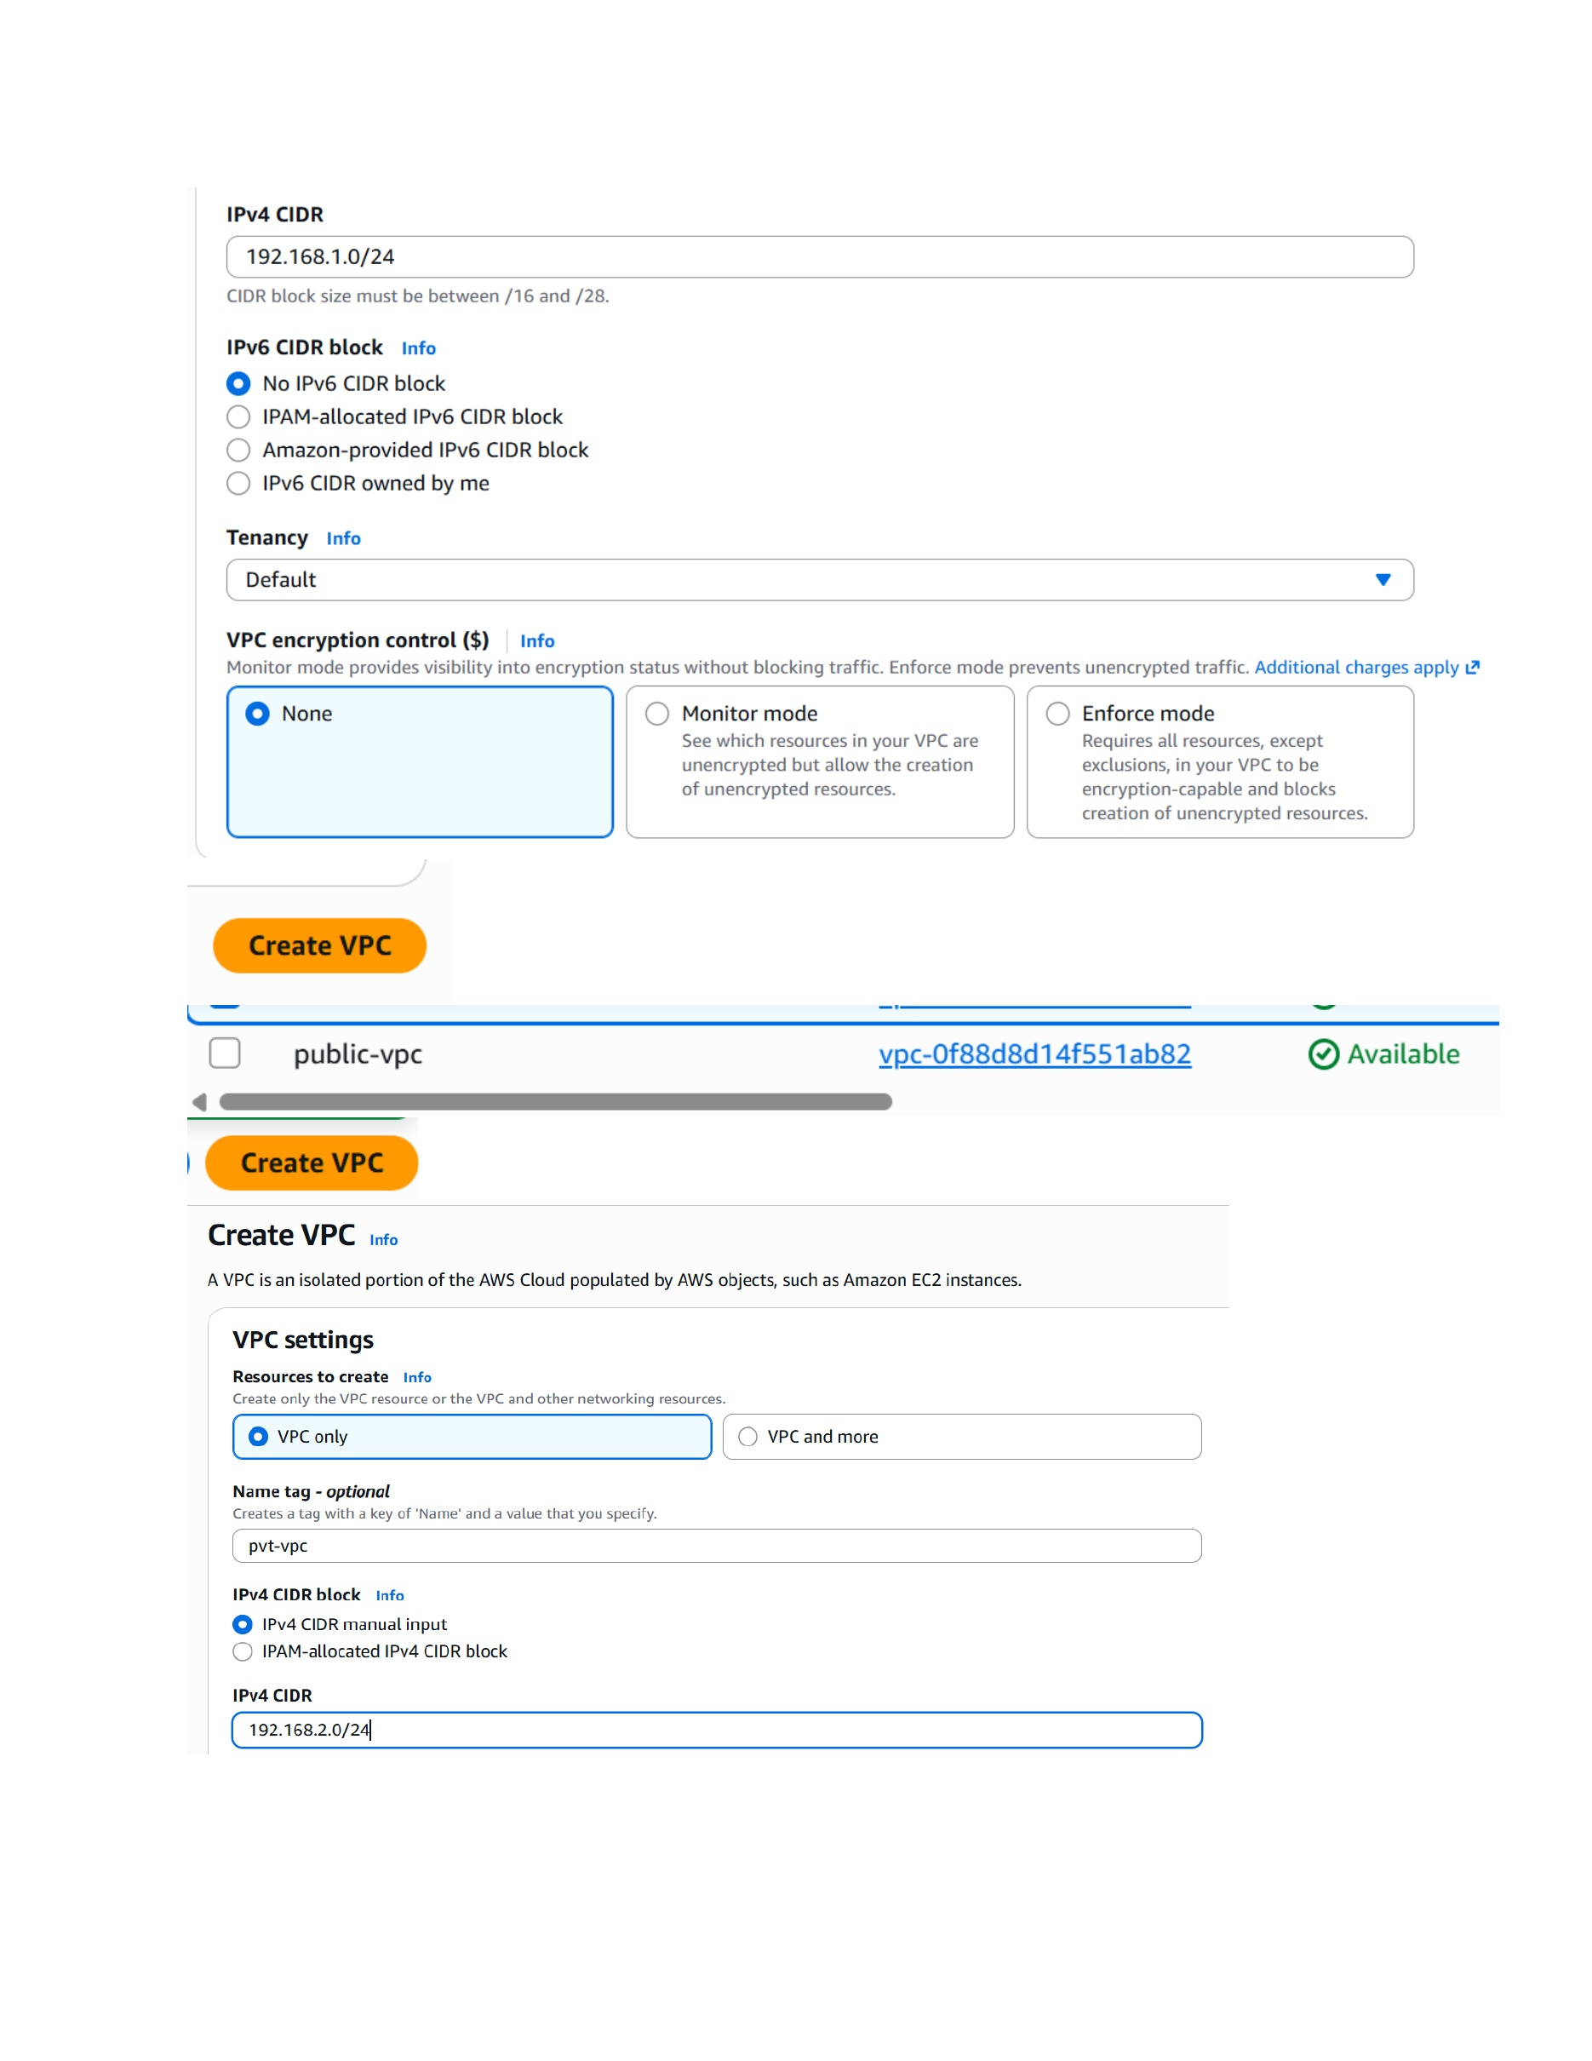
What I did: Created the public VPC and assigned the IPv4 CIDR block 192.168.1.0/24.

Create Private VPC
Topic: Create Private VPC
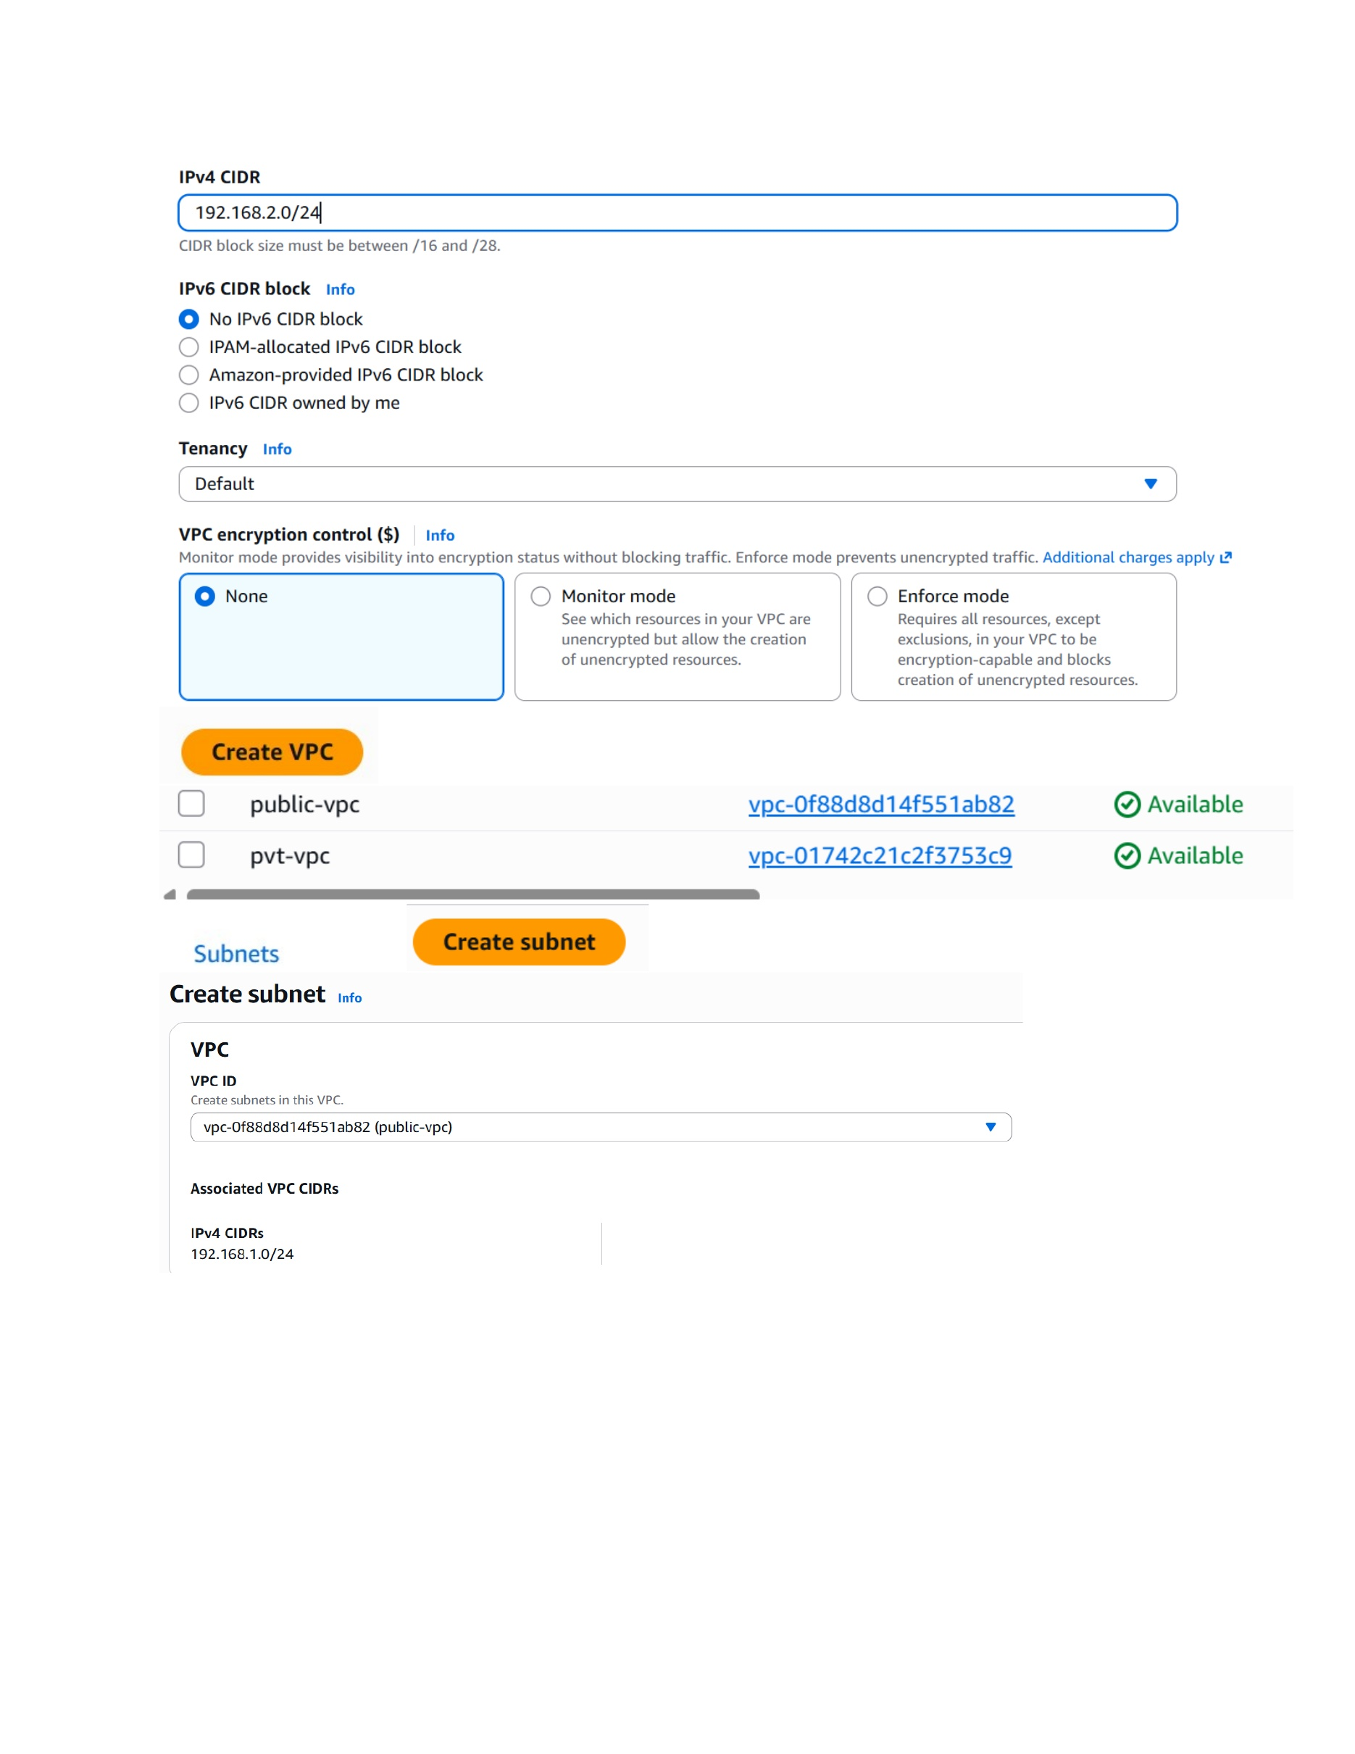
What I did: Created the private VPC and assigned the IPv4 CIDR block 192.168.2.0/24.

Create Public Subnet
Topic: Create Public Subnet
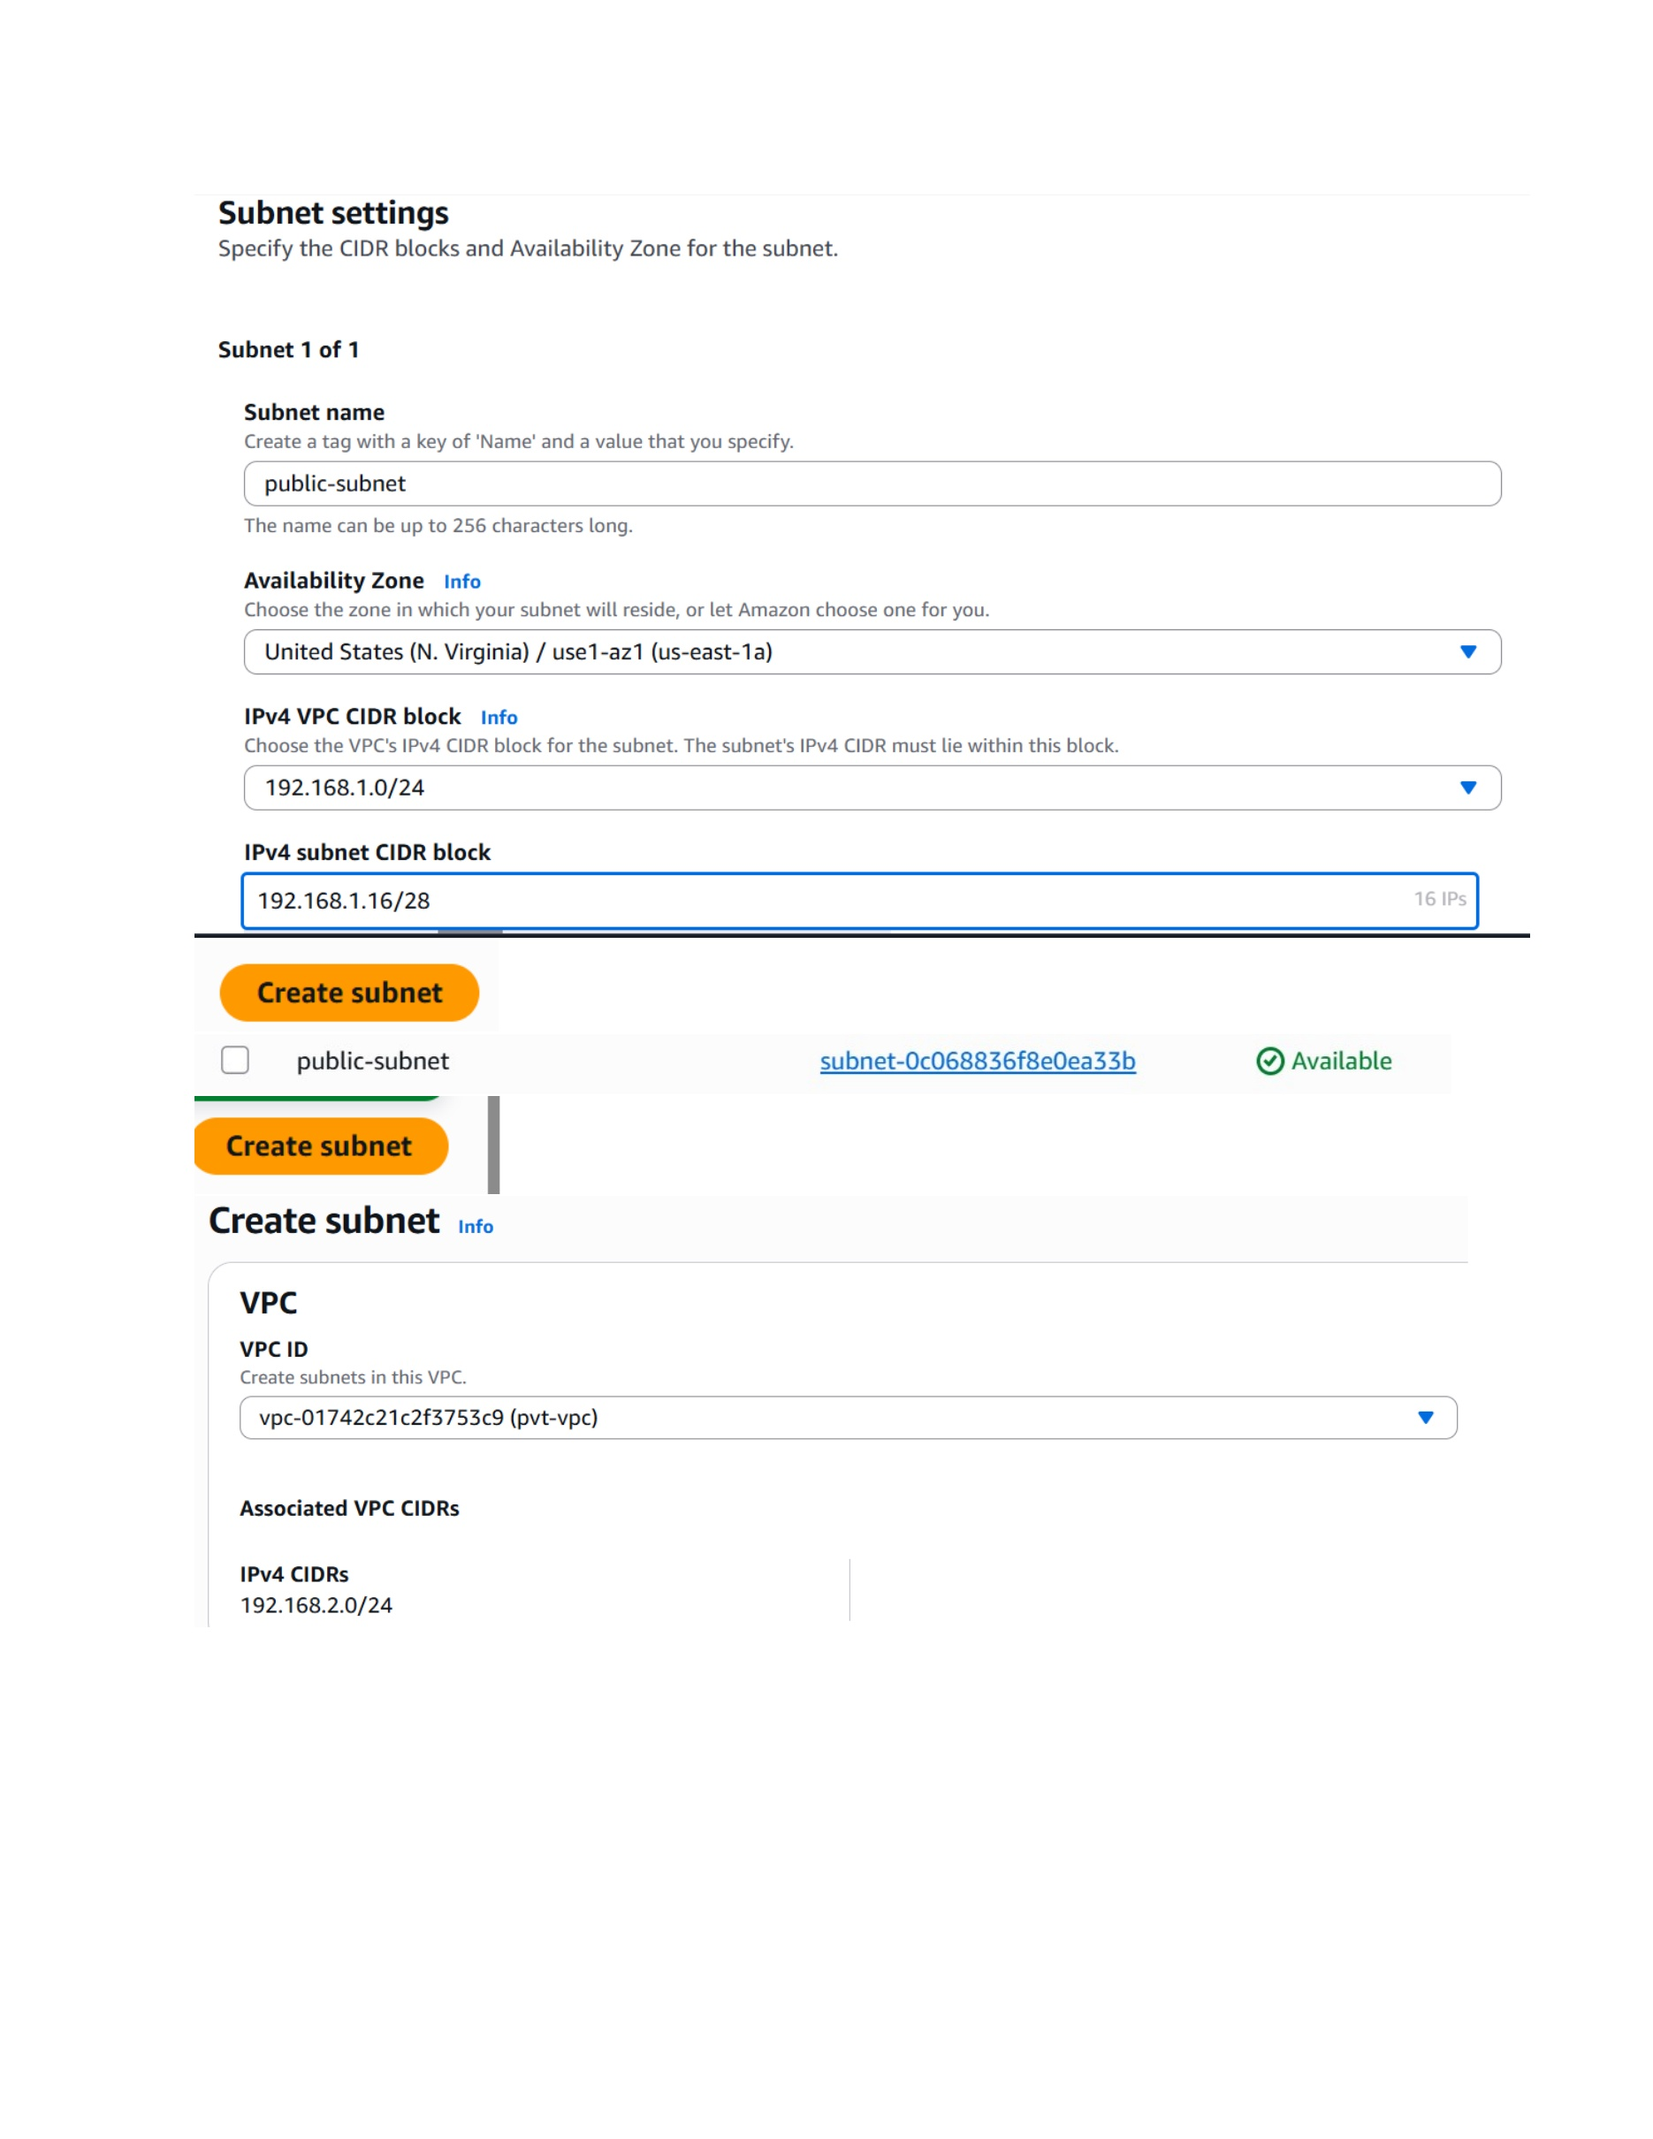
What I did: Created the public subnet inside the public VPC and selected the required Availability Zone and CIDR range.

Create Private Subnet
Topic: Create Private Subnet
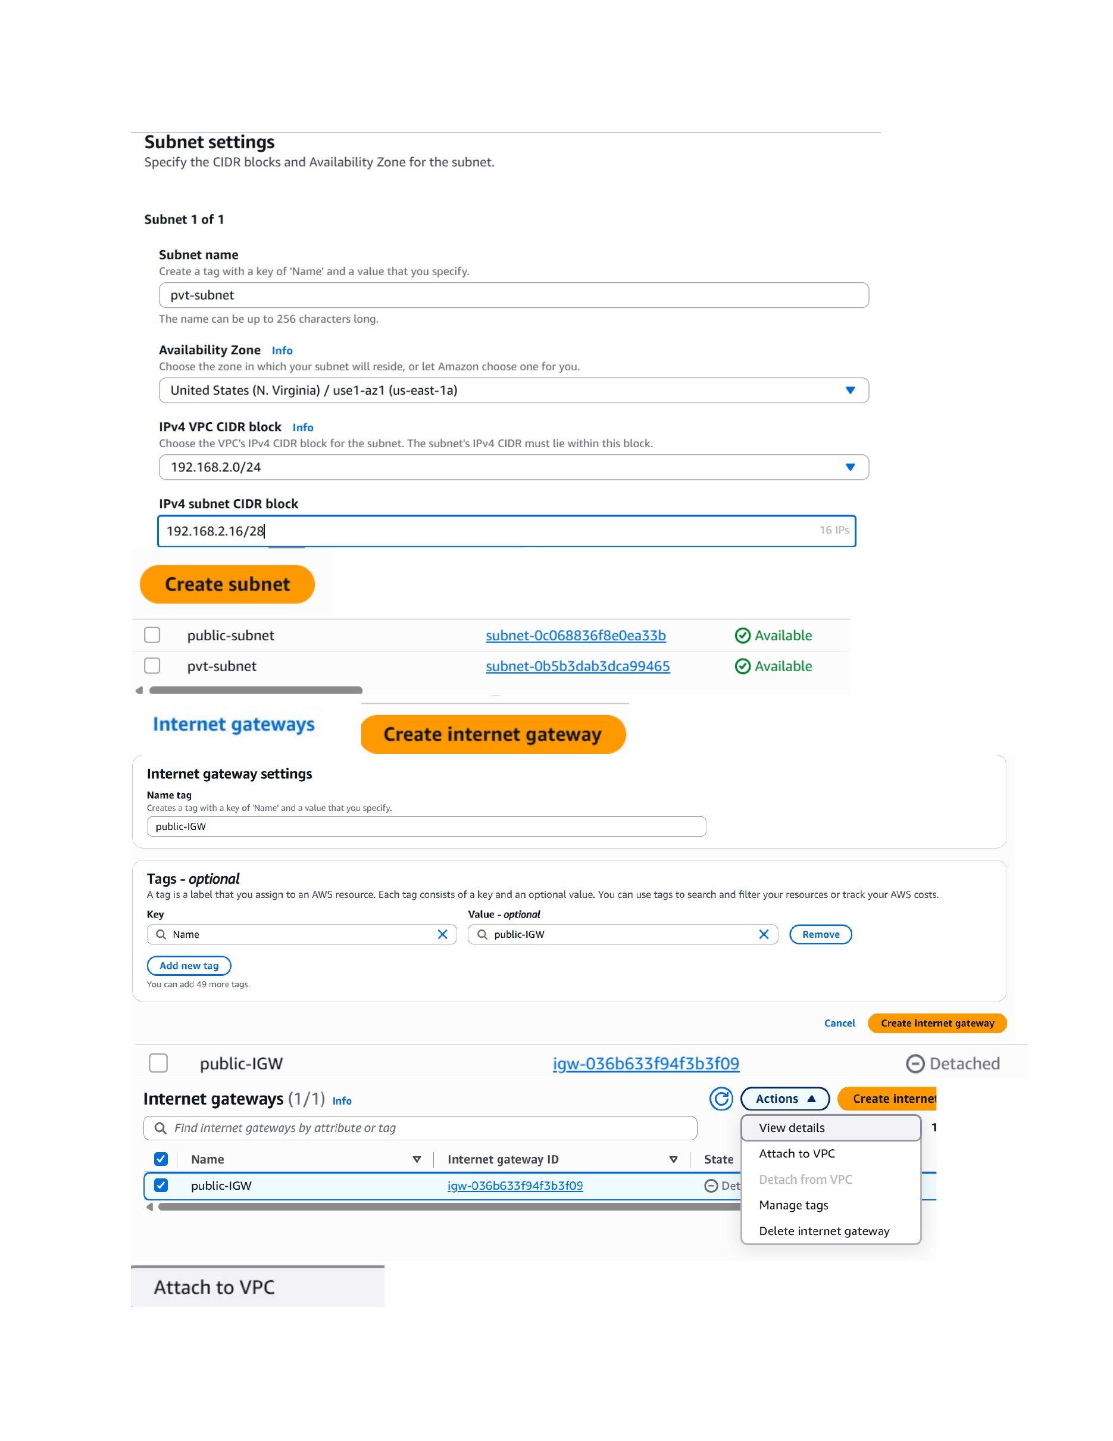
What I did: Created the private subnet inside the private VPC with its corresponding Availability Zone and CIDR range.

Internet Gateway and Public Route Table
Topic: Internet Gateway and Public Route Table
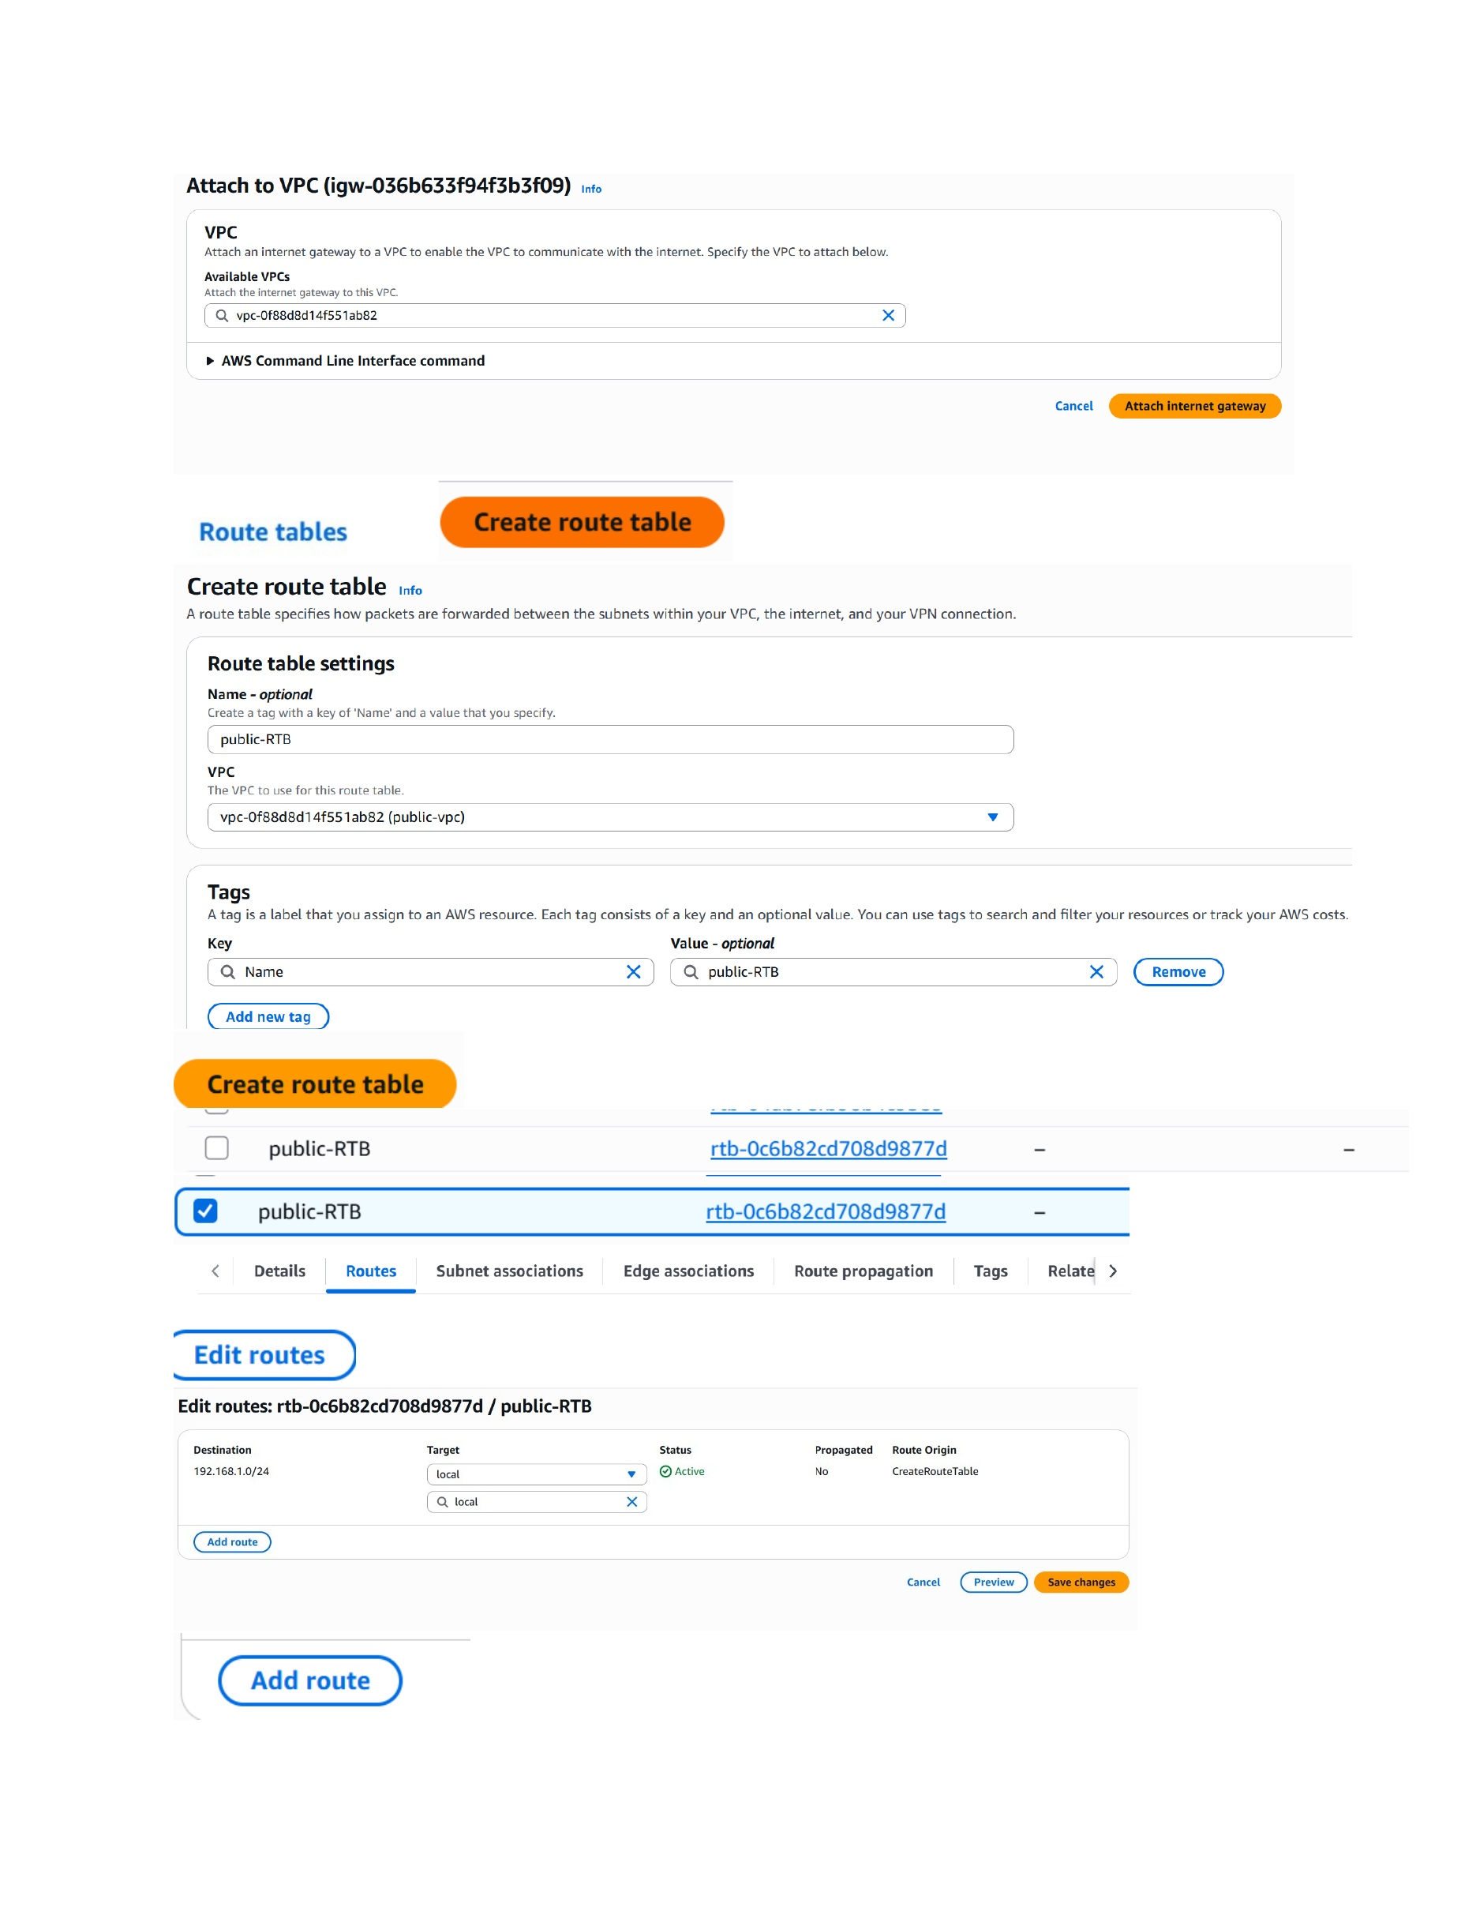
What I did: Attached the Internet Gateway to the public VPC and started creating the public route table.

Configure Public Route Table
Topic: Configure Public Route Table
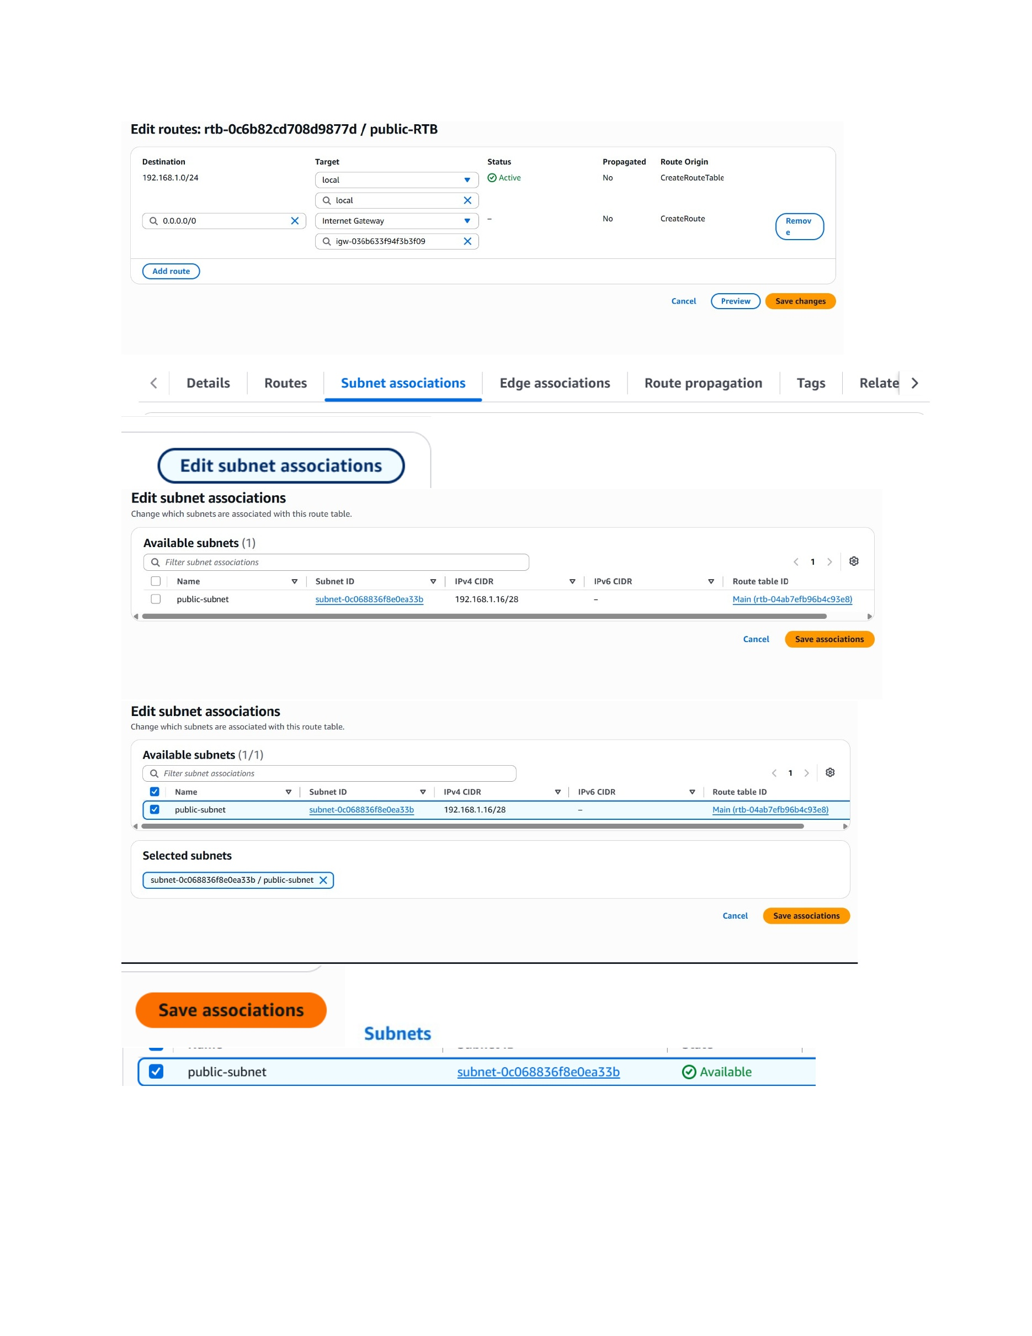
What I did: Added the Internet Gateway route for internet traffic and associated the public subnet with the public route table.

Enable Public IPv4 for Public Subnet
Topic: Enable Public IPv4 for Public Subnet
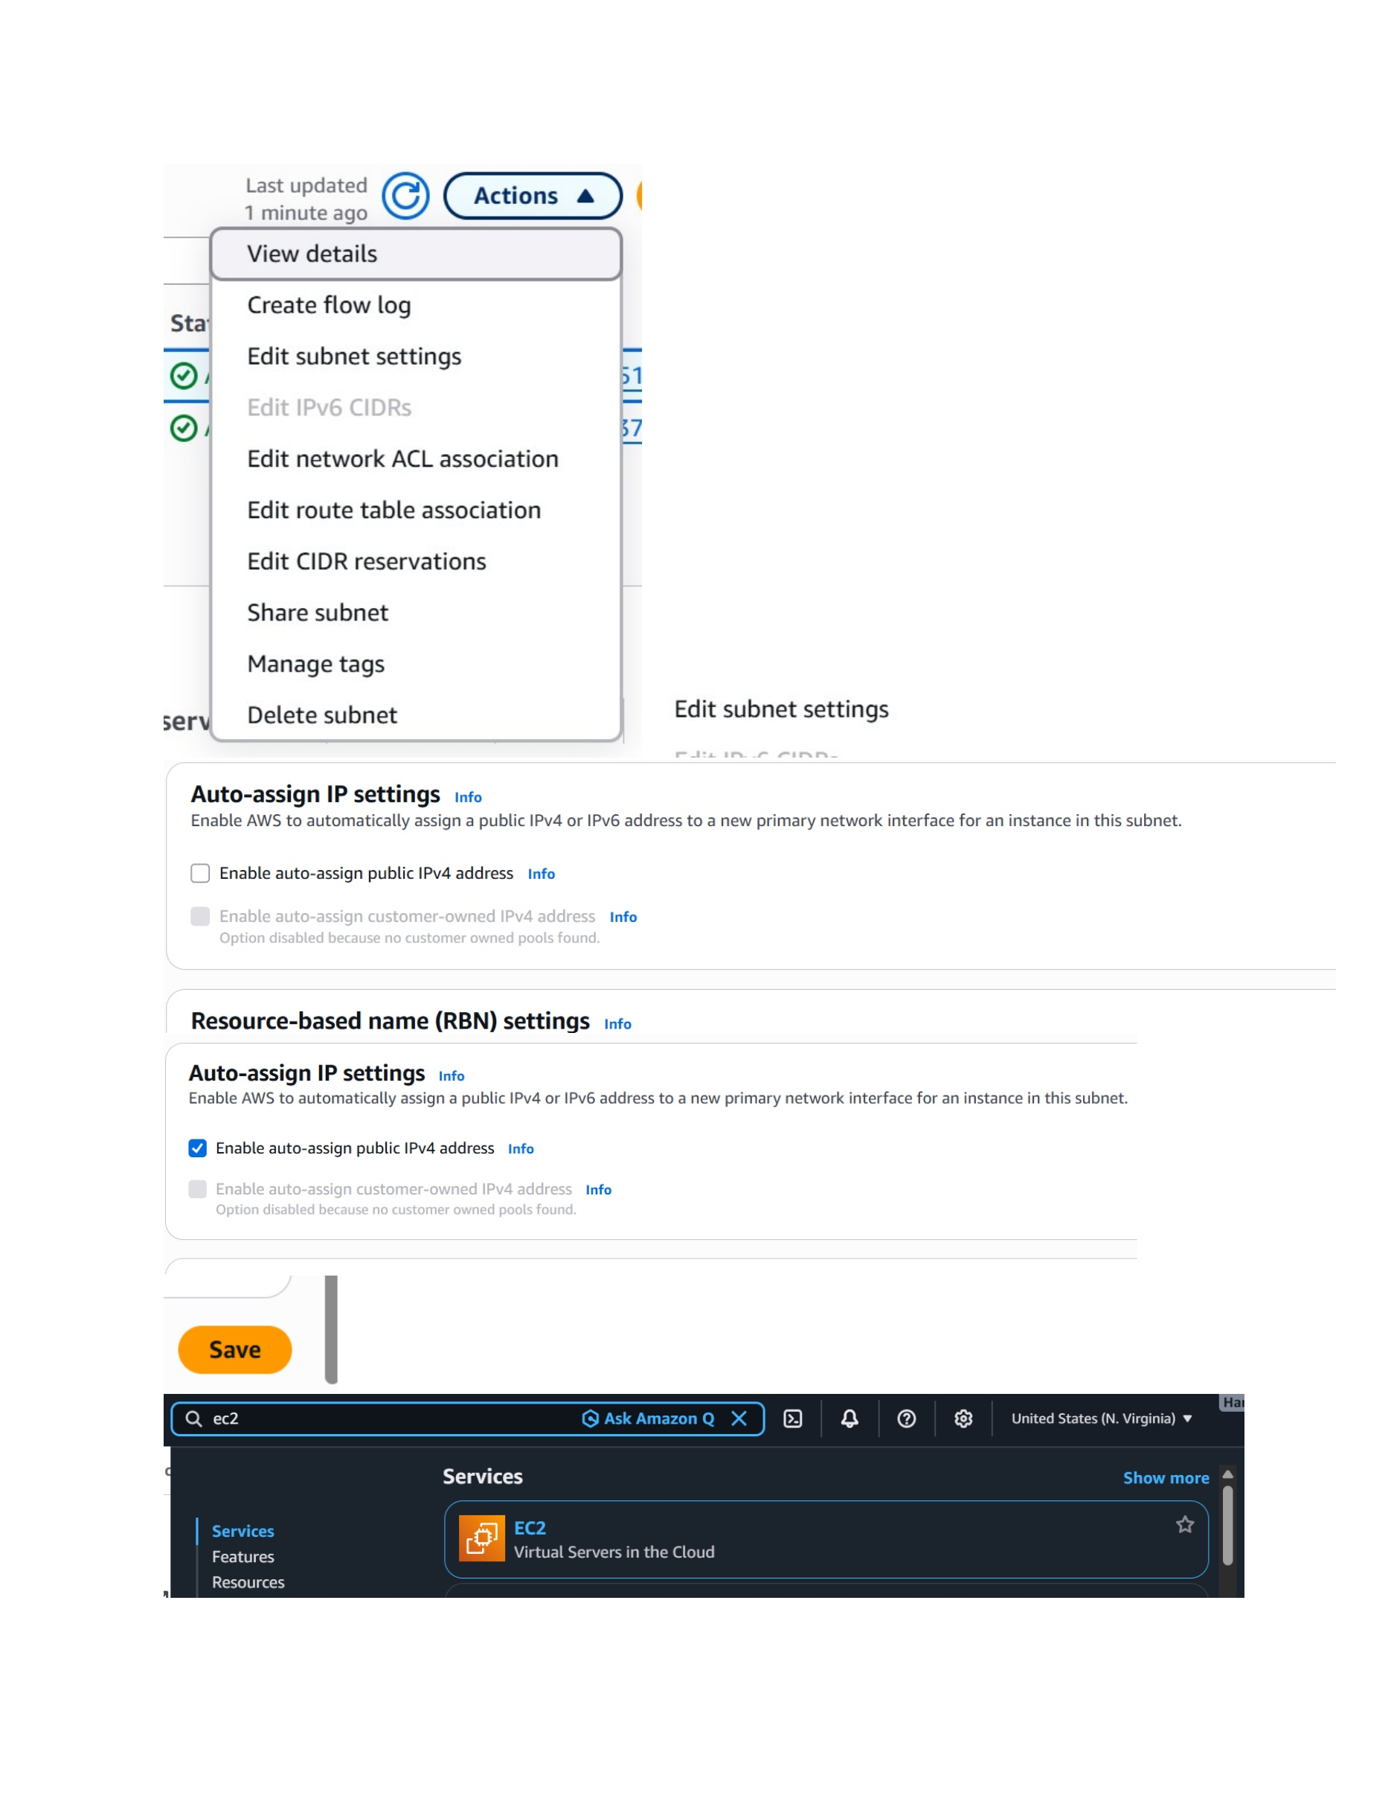
What I did: Enabled automatic assignment of public IPv4 addresses so instances launched in the public subnet can receive a public IP.

Launch Public Windows Instance
Topic: Launch Public Windows Instance
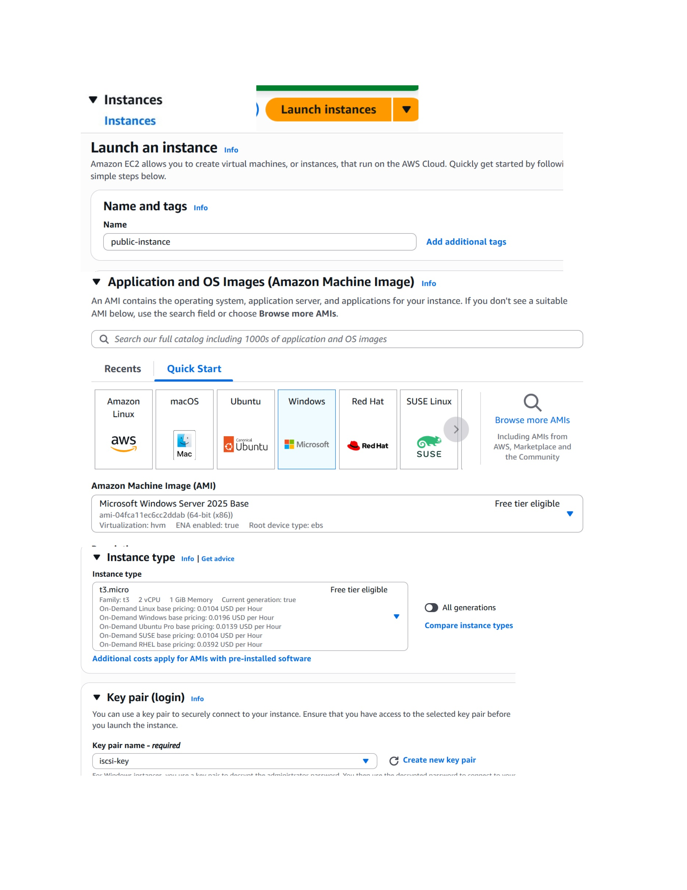
What I did: Started launching the public EC2 instance and selected the Windows AMI and required instance settings.

Configure Public Instance Networking
Topic: Configure Public Instance Networking
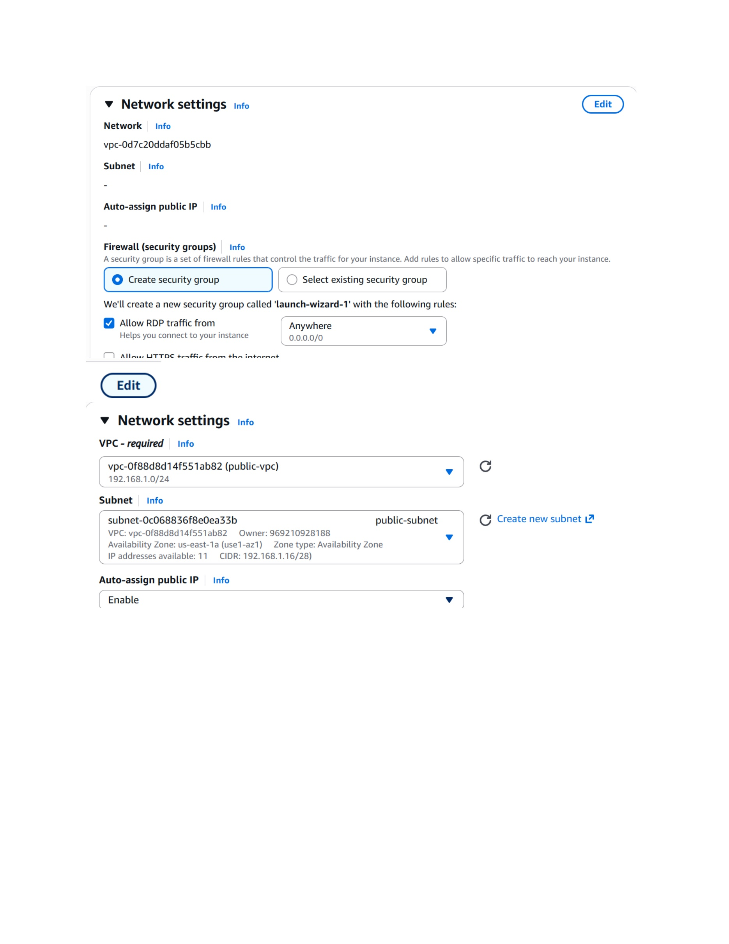
What I did: Selected the public VPC/subnet and configured the network and security-group settings for the Windows instance.

Create Public Security Group
Topic: Create Public Security Group
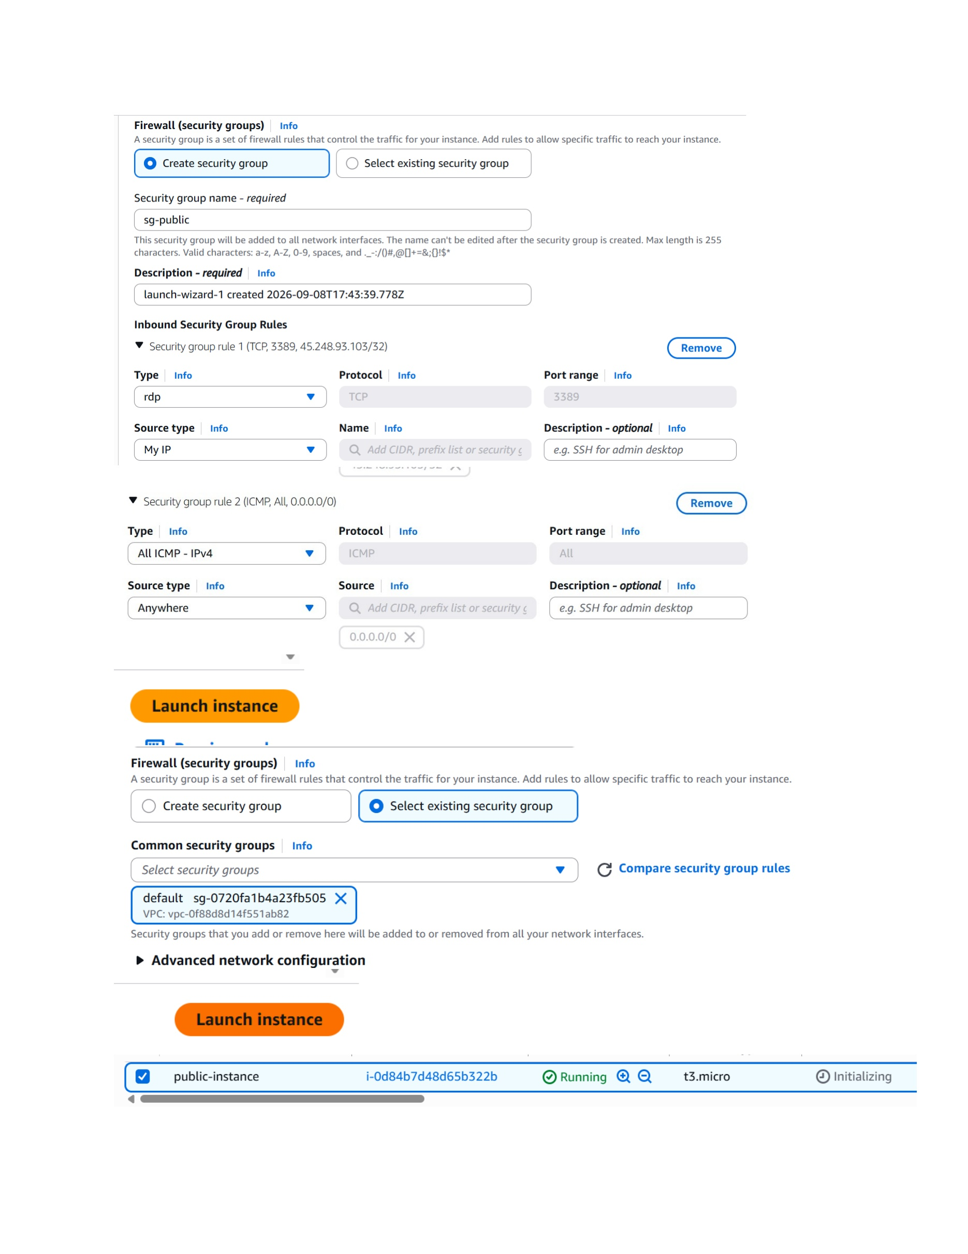
What I did: Created the public security group and configured it to control inbound traffic to the Windows instance.

Configure Security Group Rules
Topic: Configure Security Group Rules
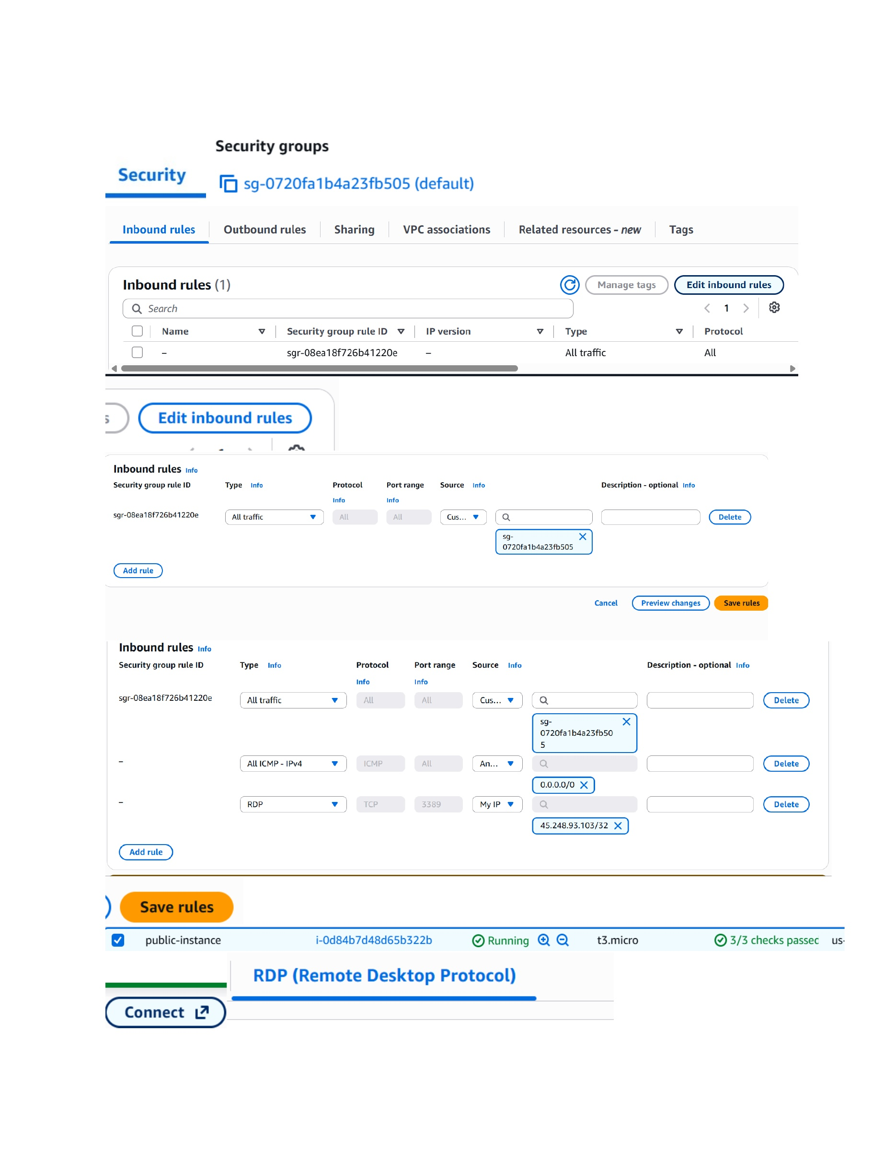
What I did: Reviewed and edited the inbound security-group rules for the public instance.

Get Windows Administrator Password
Topic: Get Windows Administrator Password
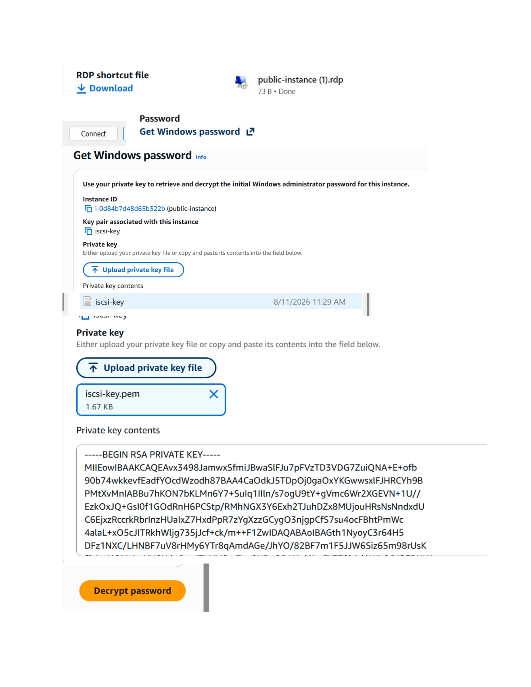
What I did: Used the EC2 Get Windows Password option and supplied the associated private key to retrieve the Windows administrator credentials.

Windows RDP Credentials
Topic: Windows RDP Credentials
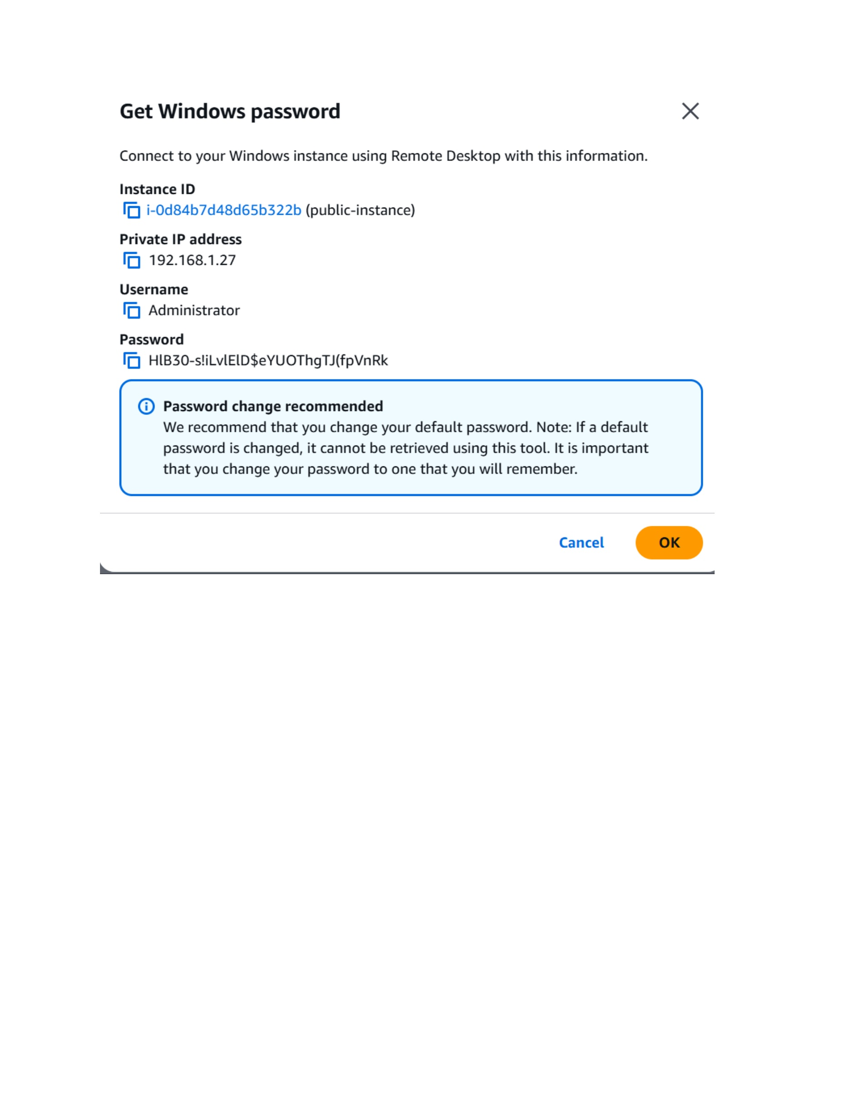
What I did: Displayed the decrypted Windows administrator username, password, and connection information for the public instance.

Start Remote Desktop Connection
Topic: Start Remote Desktop Connection
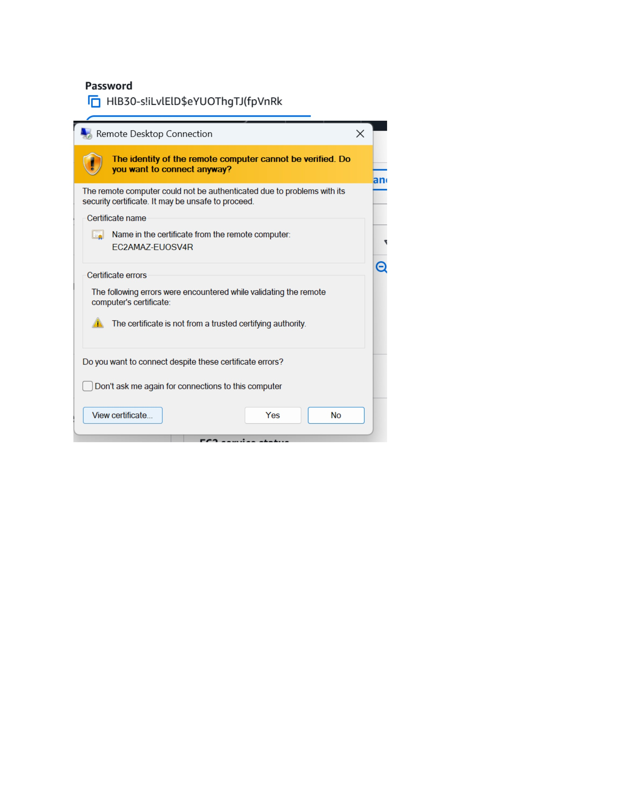
What I did: Started an RDP connection to the public Windows instance and accepted the certificate warning to continue.

Open Windows Firewall Settings
Topic: Open Windows Firewall Settings
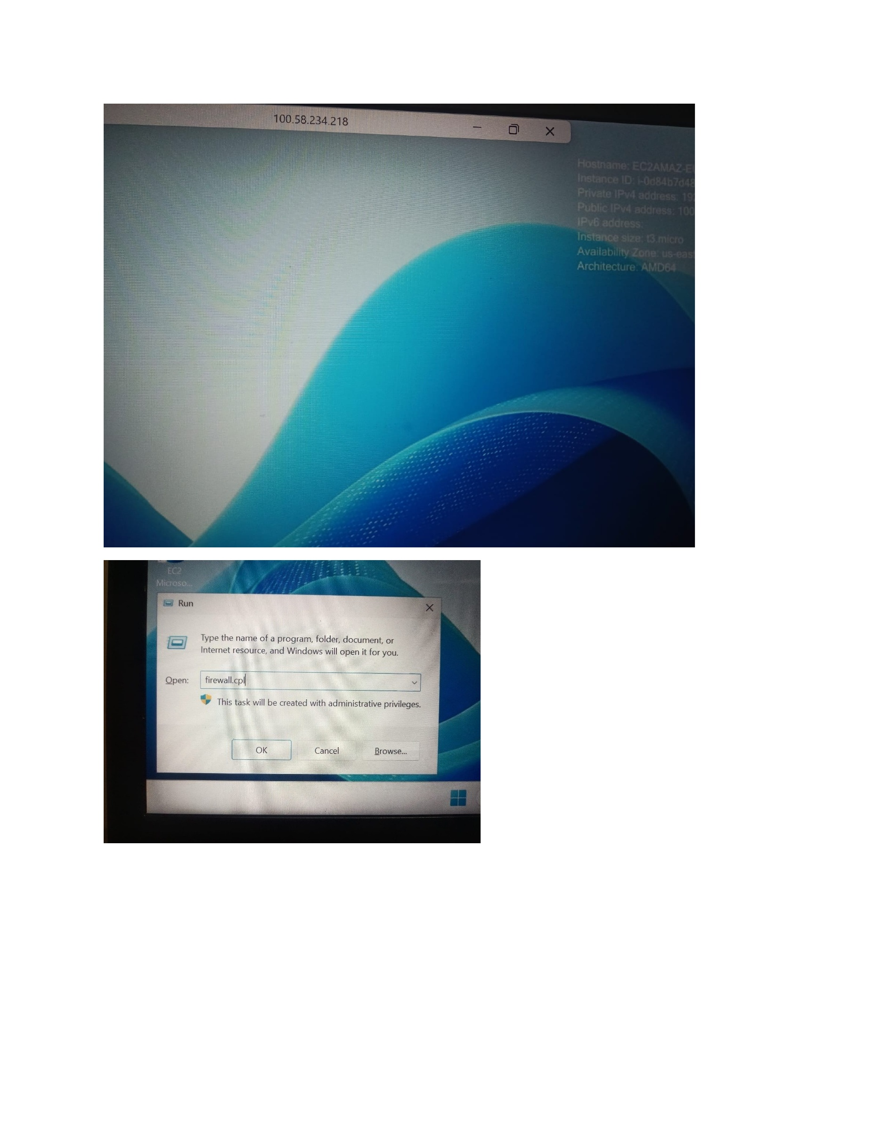
What I did: Opened Windows firewall settings on the connected Windows machine to prepare the required network access.

Windows Network/Firewall Check
Topic: Windows Network/Firewall Check
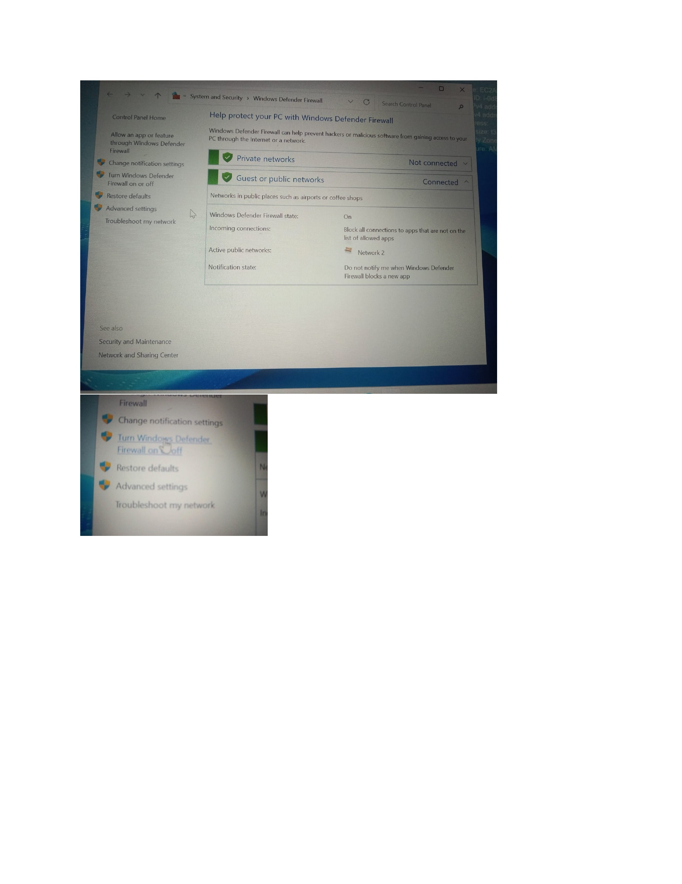
What I did: Reviewed the Windows firewall/network configuration shown on the desktop before connectivity testing.

Windows Configuration Check
Topic: Windows Configuration Check
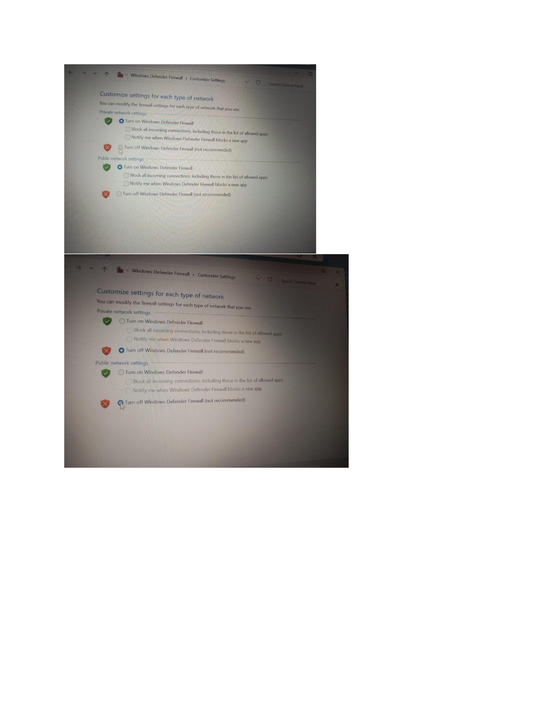
What I did: Continued checking the Windows system configuration needed for network communication.

Ping Connectivity Test
Topic: Ping Connectivity Test
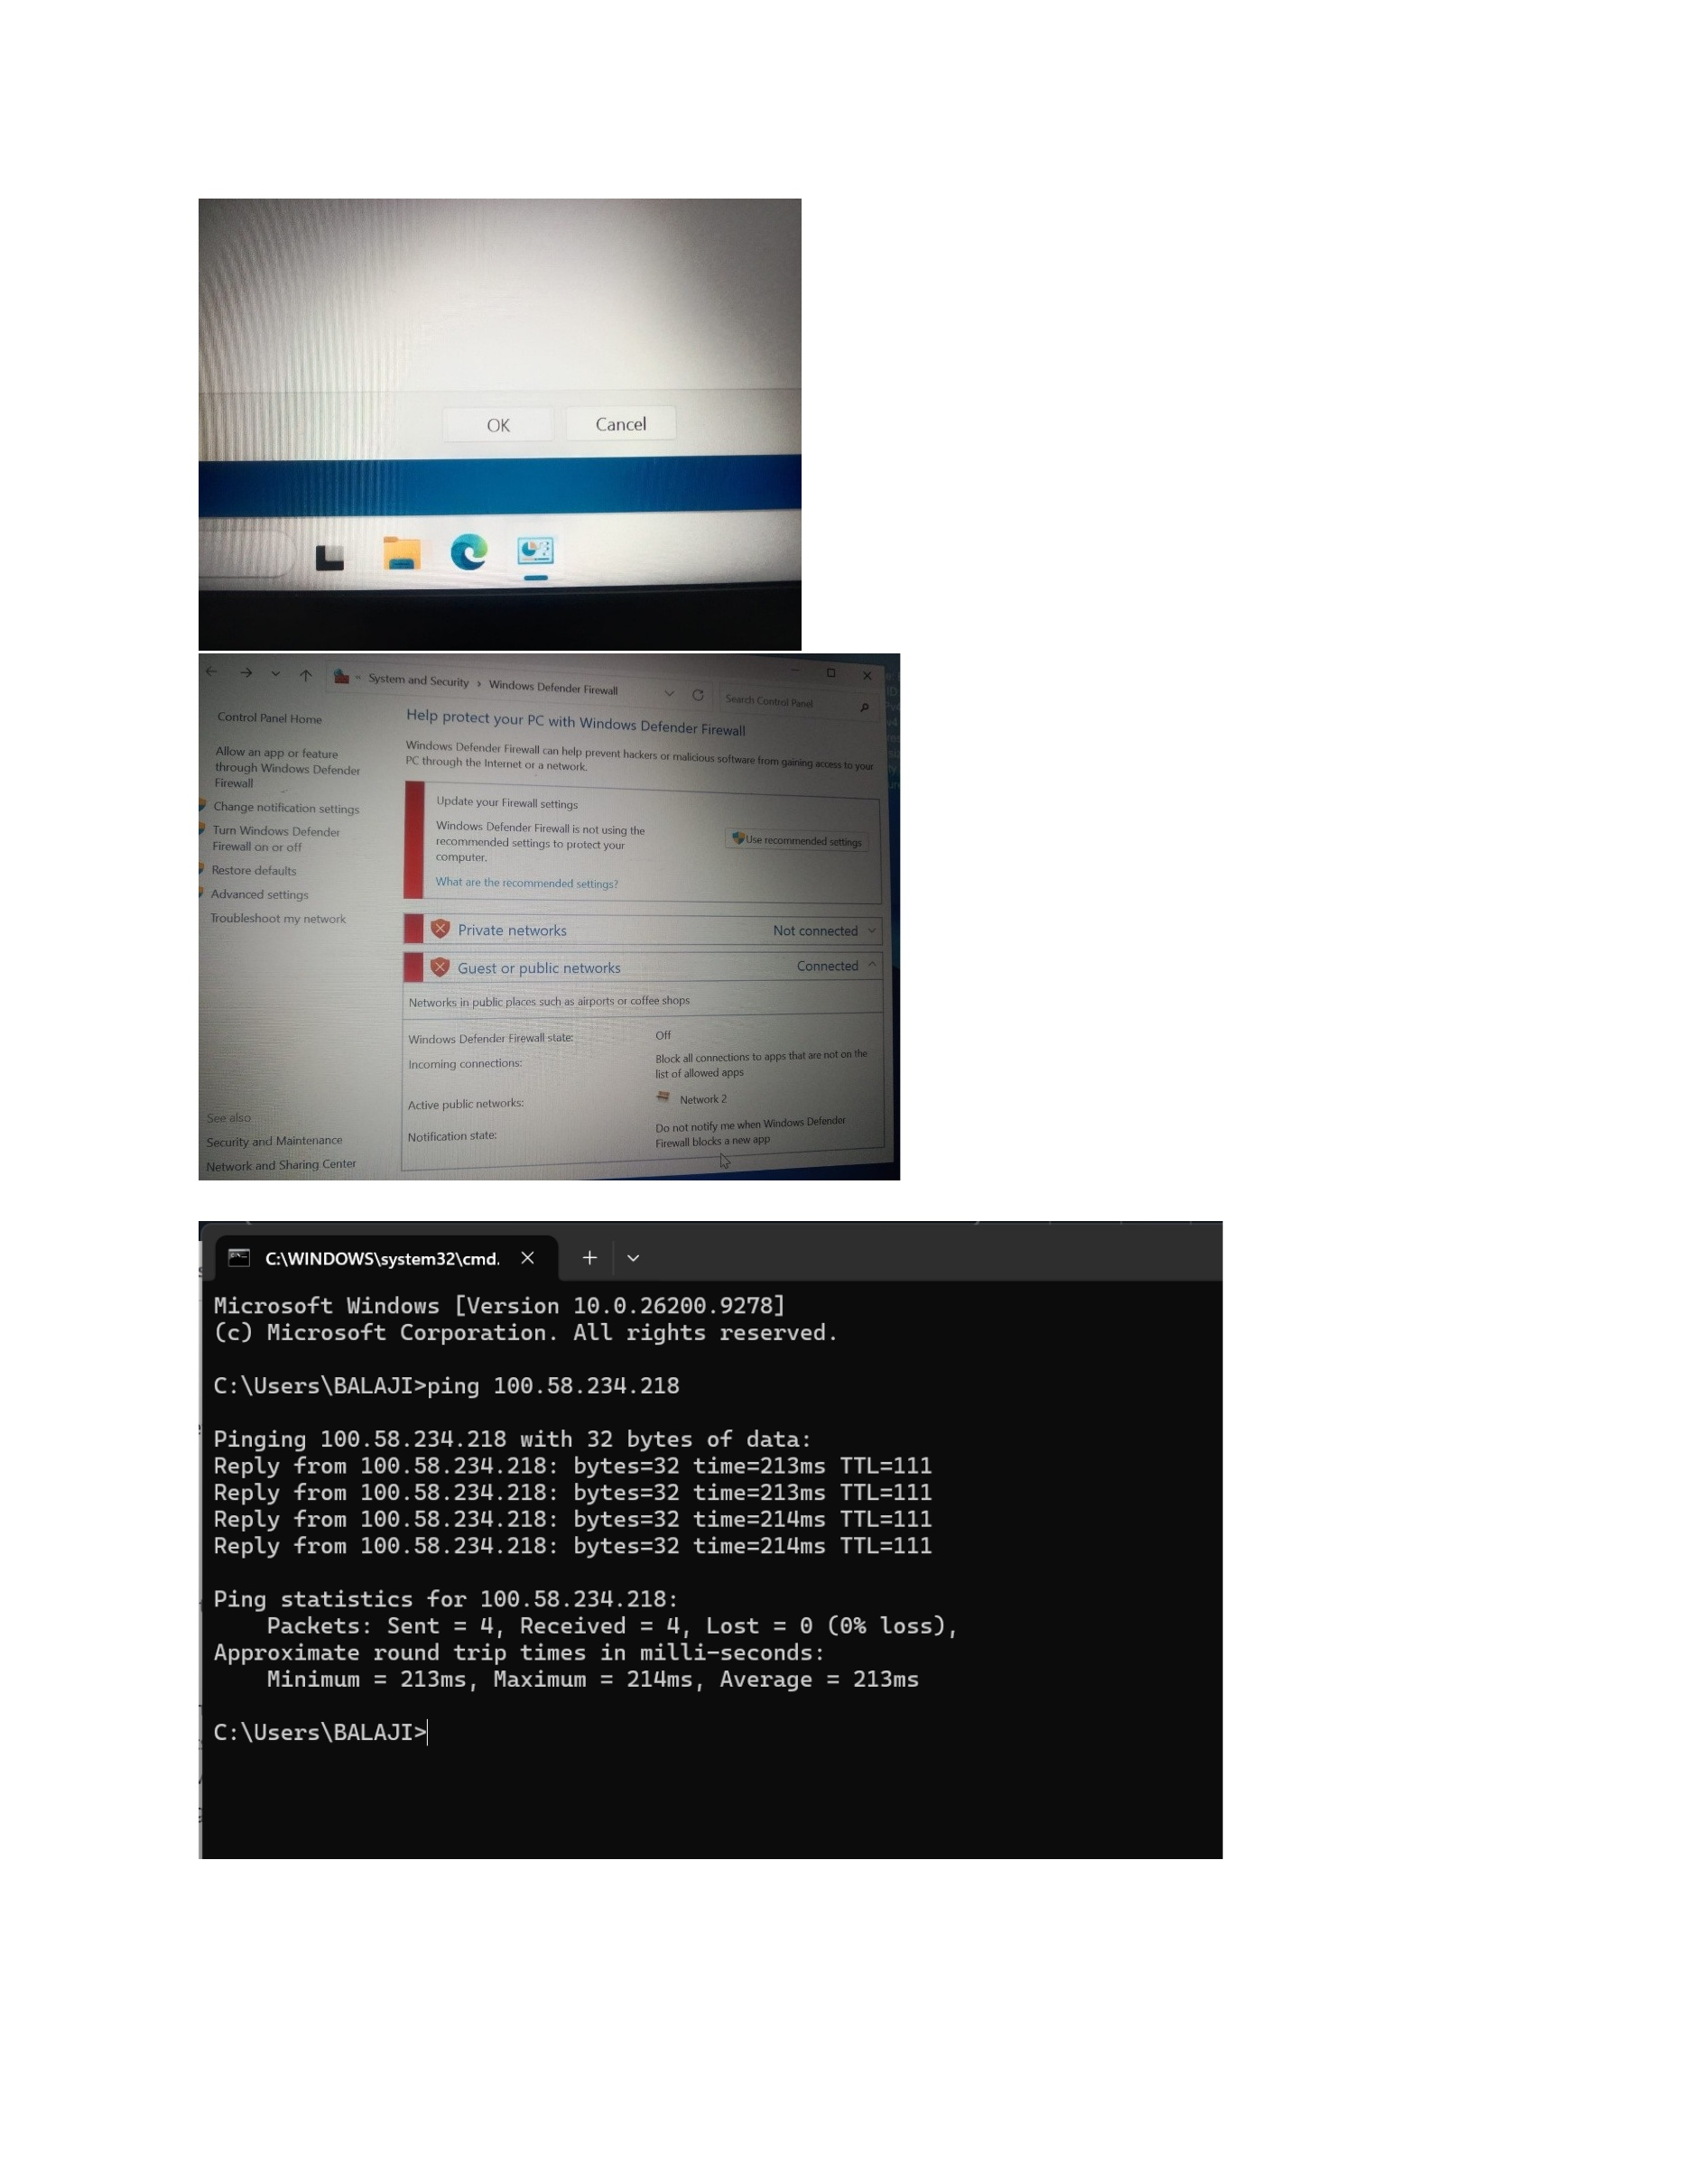
What I did: Ran a ping command from Windows and received replies, confirming the connectivity test shown in the screenshot.

Edit Inbound Rules
Topic: Edit Inbound Rules
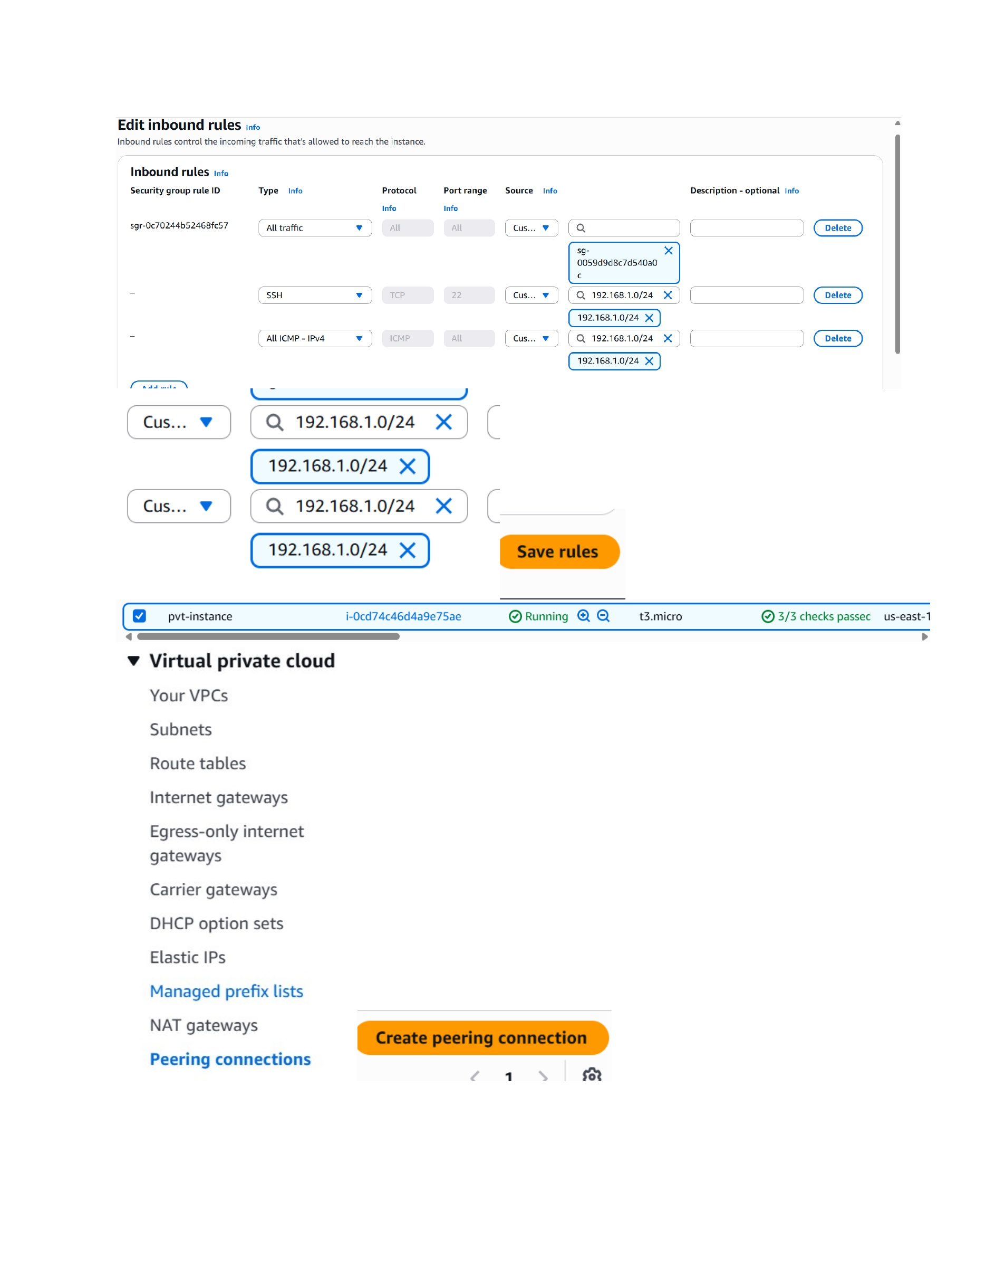
What I did: Modified inbound security-group rules to allow the required private-network traffic for the connectivity setup.

Create VPC Peering Connection
Topic: Create VPC Peering Connection
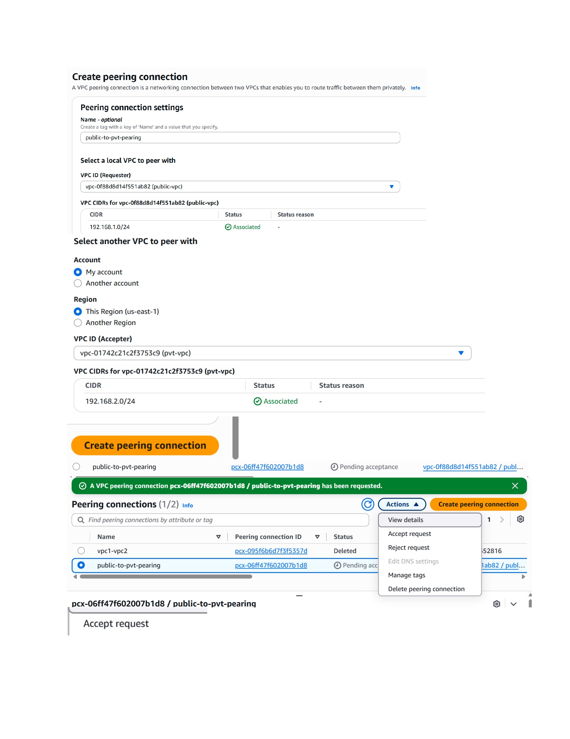
What I did: Created a VPC peering connection between the public VPC and the private VPC.

Accept VPC Peering Request
Topic: Accept VPC Peering Request
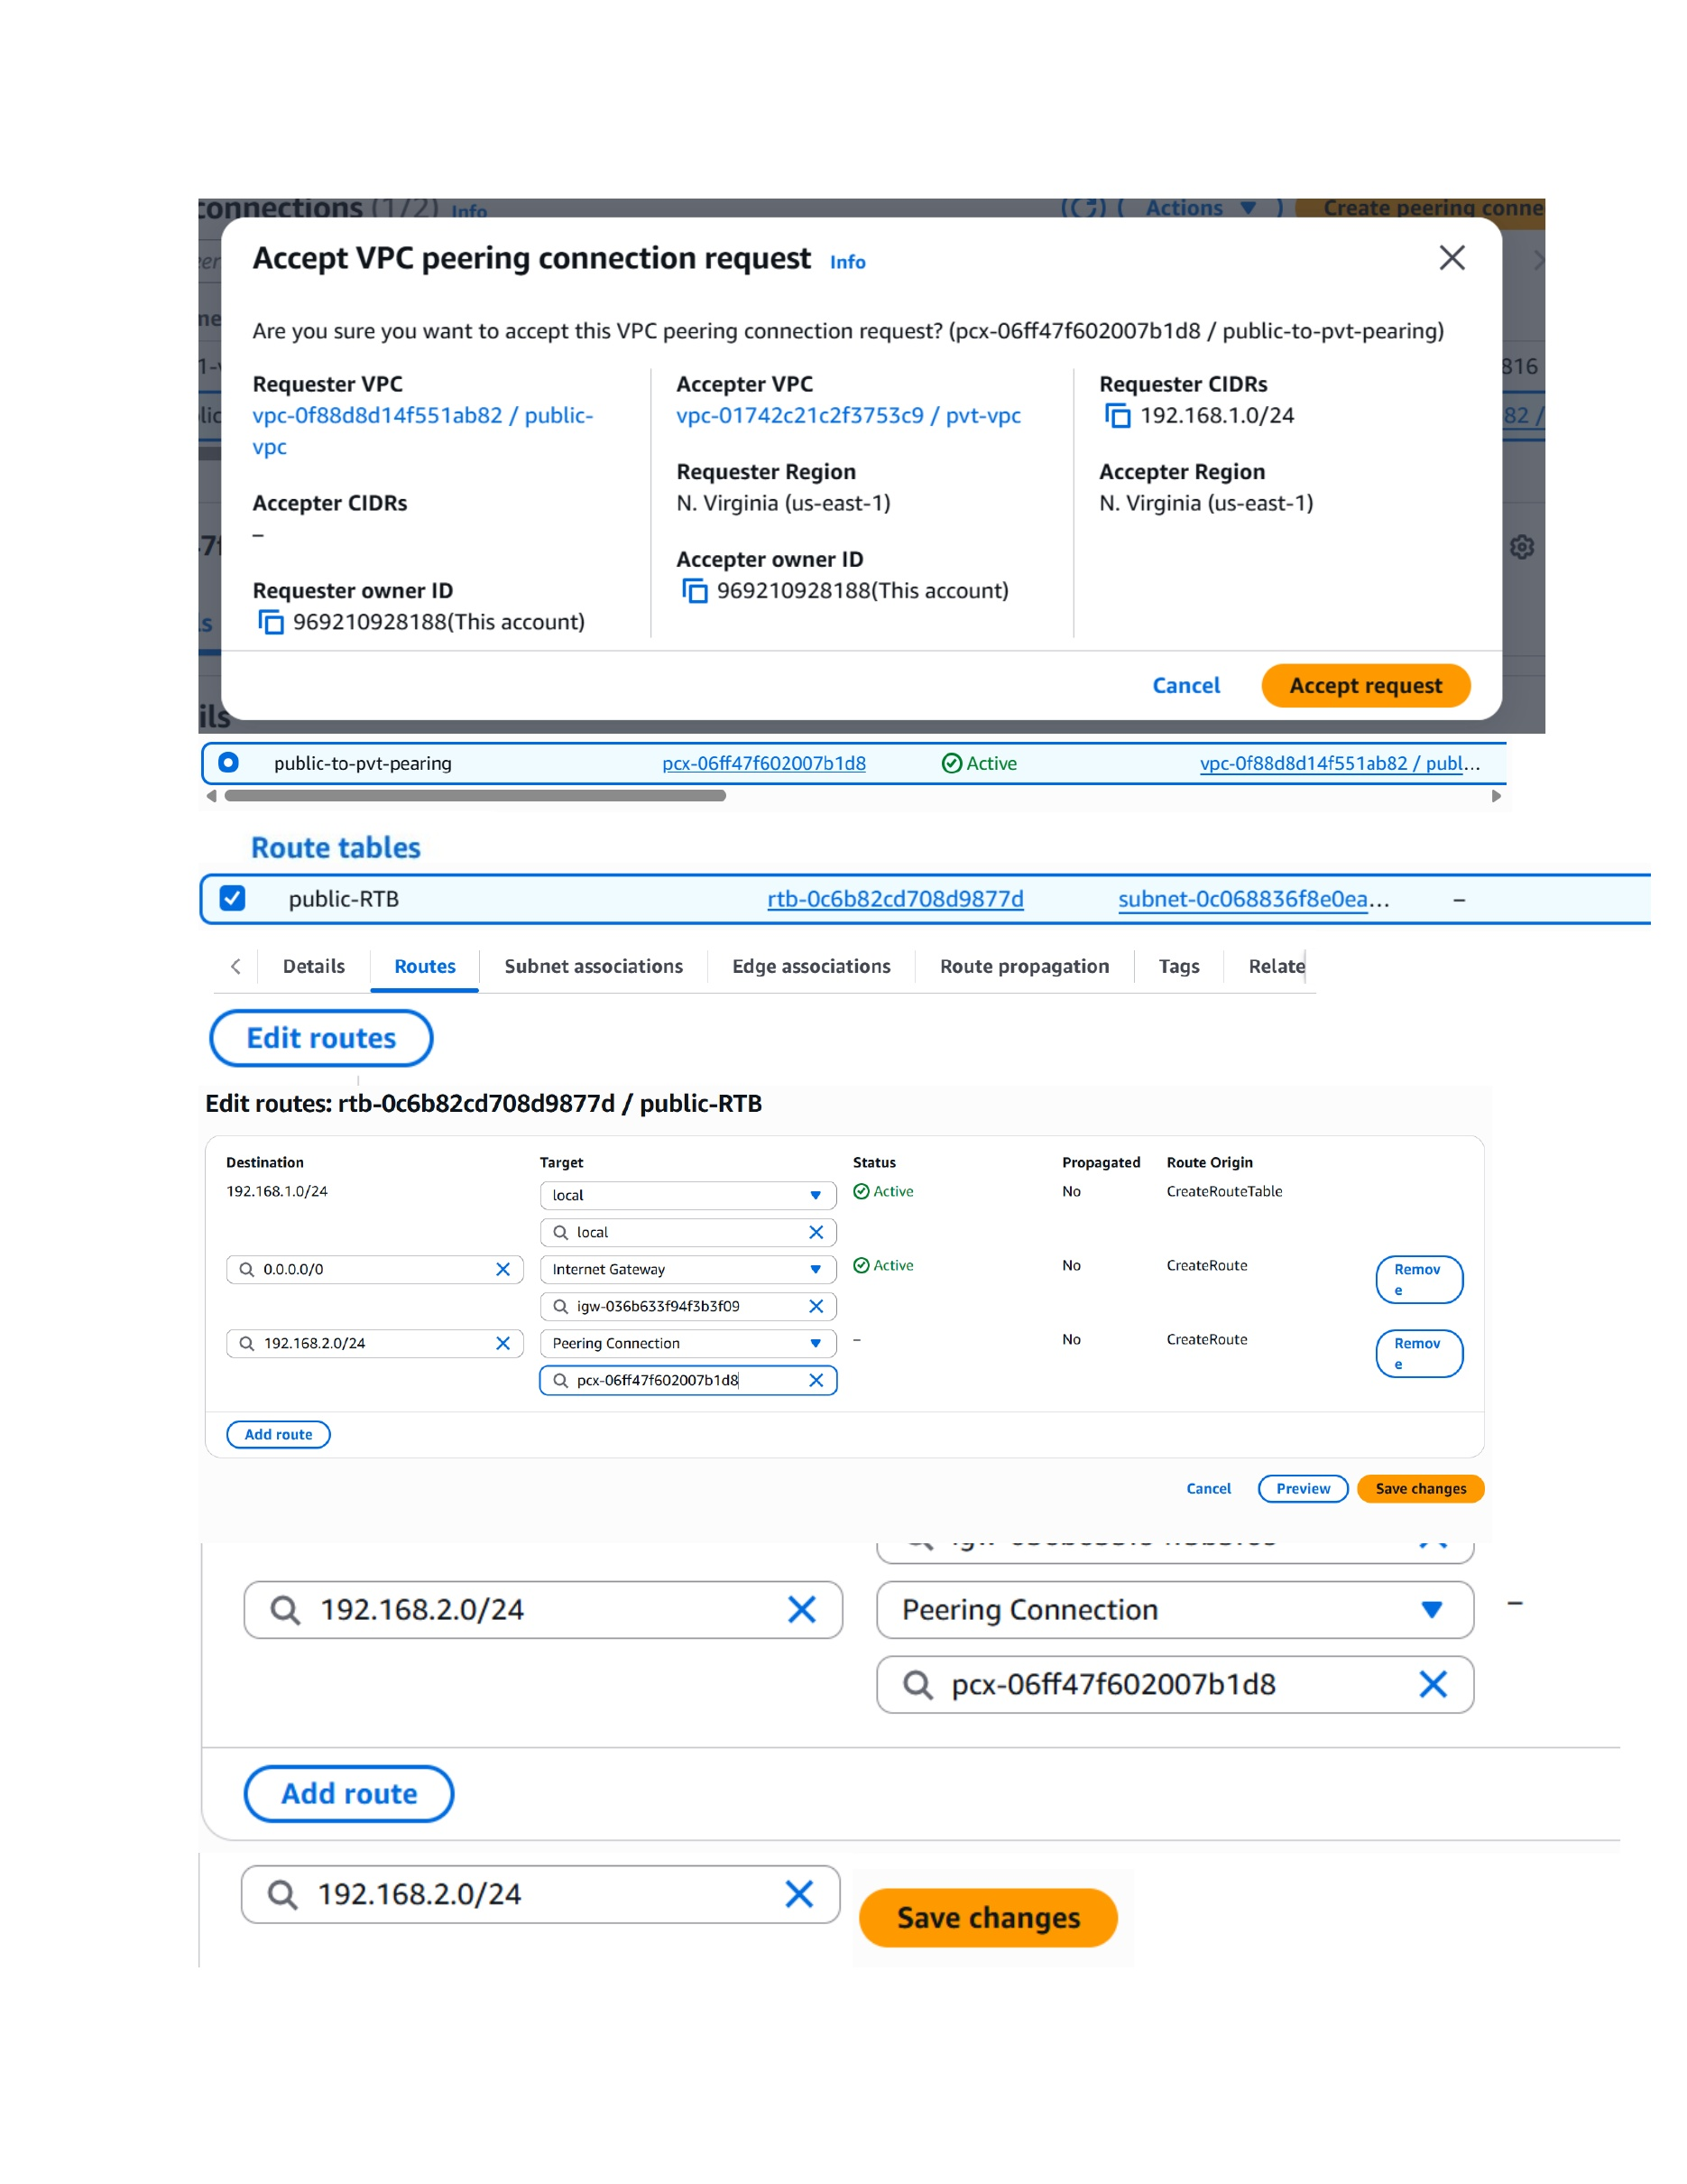
What I did: Accepted the VPC peering request so the connection between the two VPCs became active.

Add Private Route to Peering Connection
Topic: Add Private Route to Peering Connection
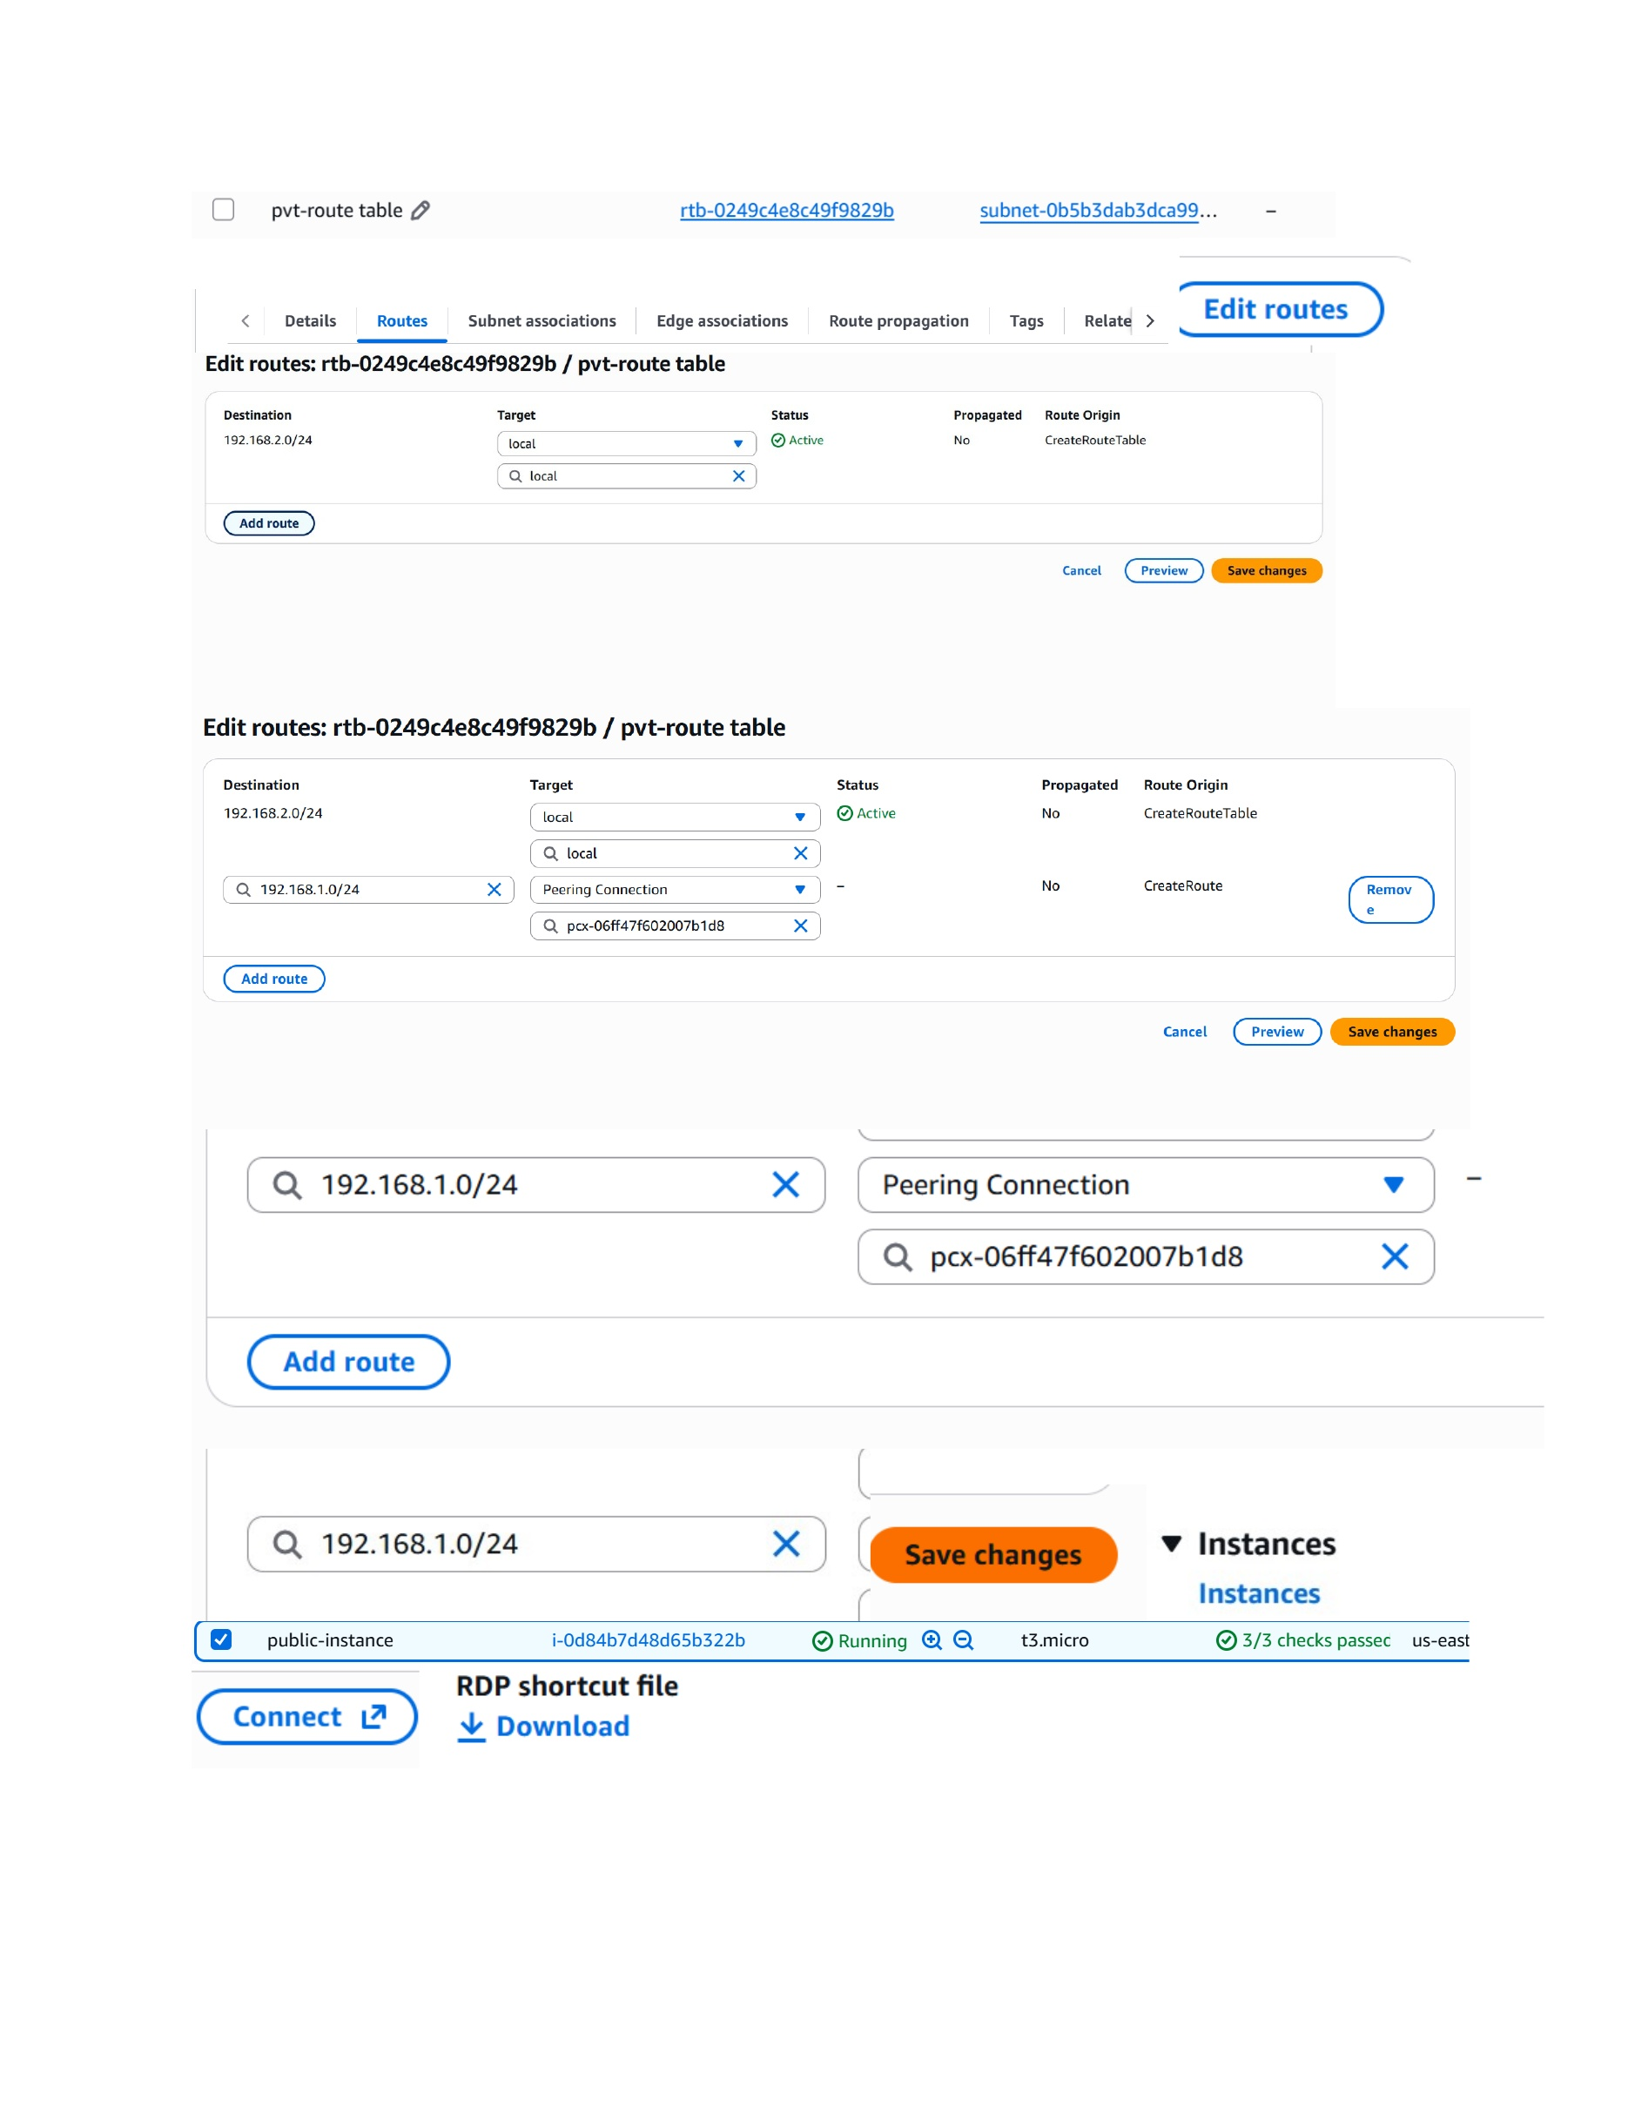
What I did: Added a route for the public VPC CIDR 192.168.1.0/24 through the VPC peering connection in the private route table.

Remote Desktop Security Prompt
Topic: Remote Desktop Security Prompt
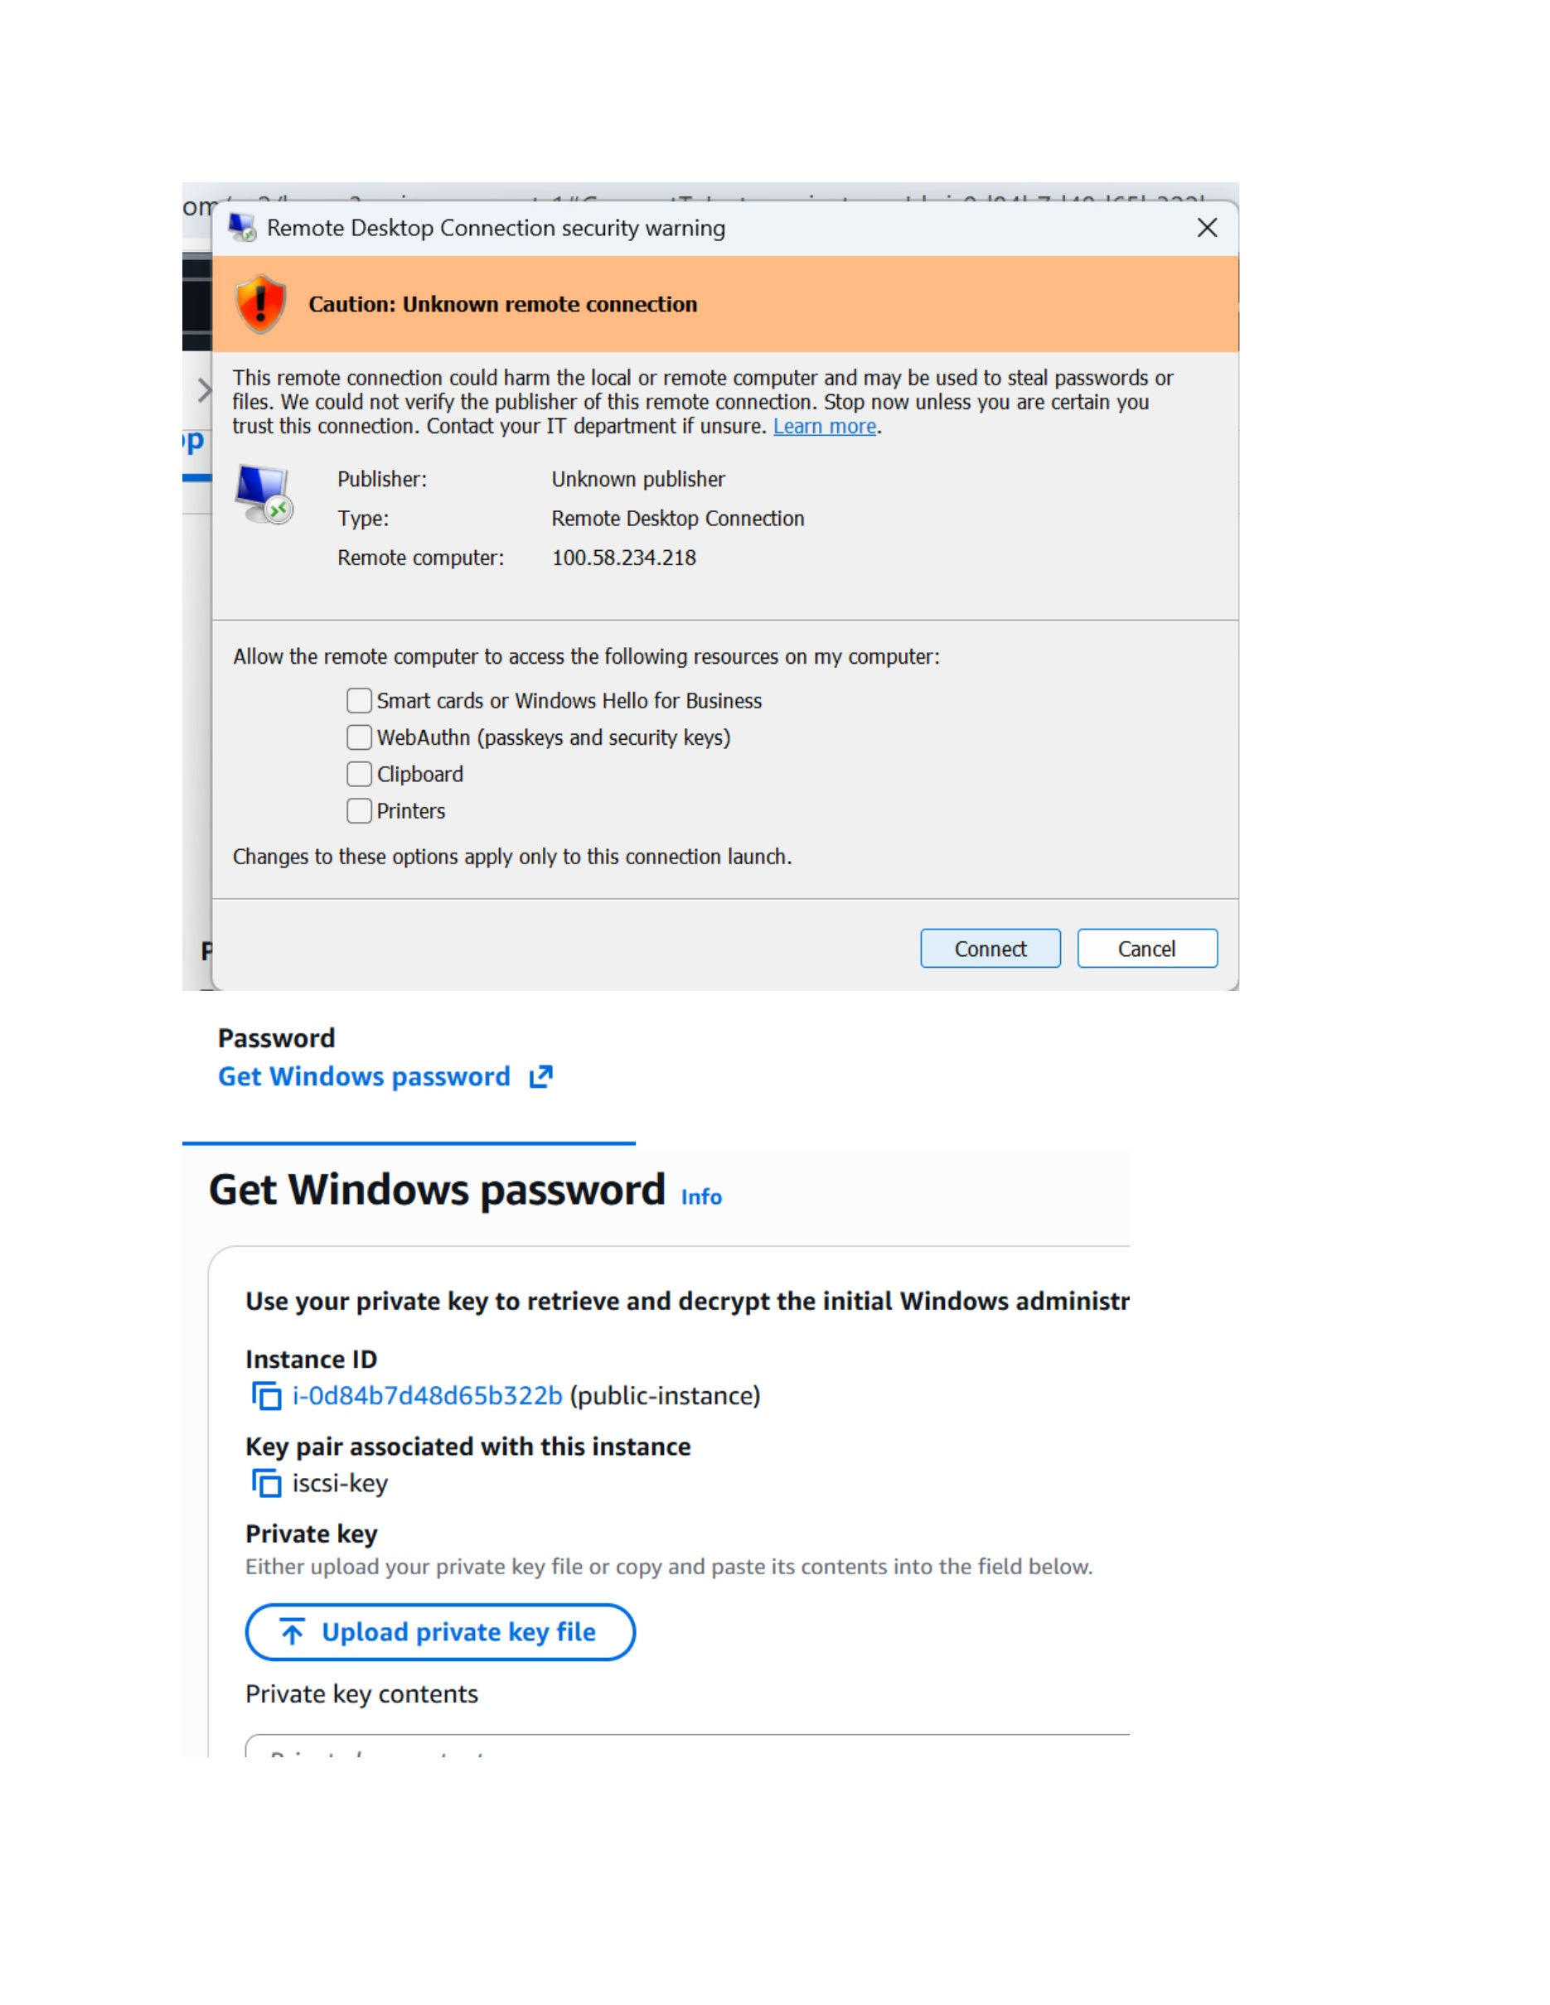
What I did: Displayed the Remote Desktop security prompt while connecting to the Windows instance.

Use Private Key for Connection
Topic: Use Private Key for Connection
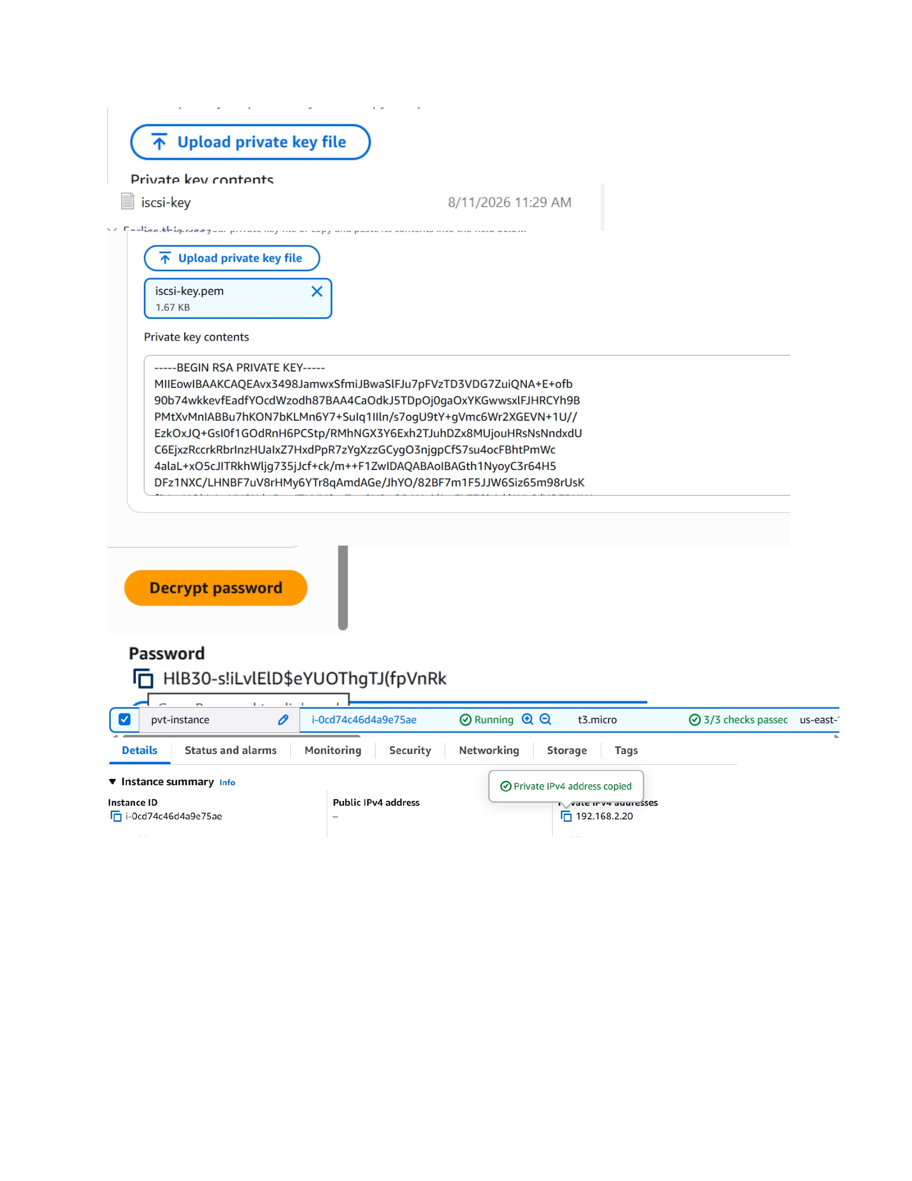
What I did: Selected the private key file and used the key/password information required for the EC2 connection.

Create Private Route Table
Topic: Create Private Route Table
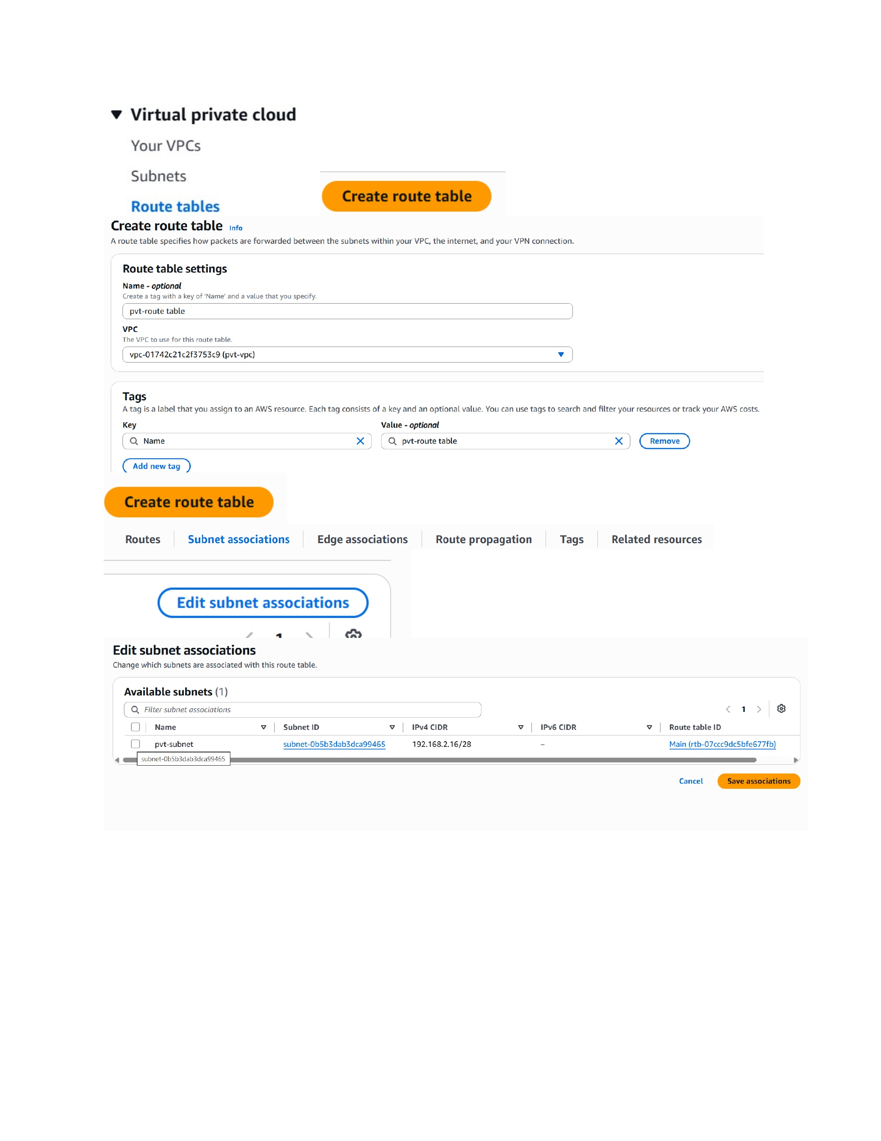
What I did: Created the private route table and associated it with the private VPC.

Associate Private Subnet and Start RHEL Instance
Topic: Associate Private Subnet and Start RHEL Instance
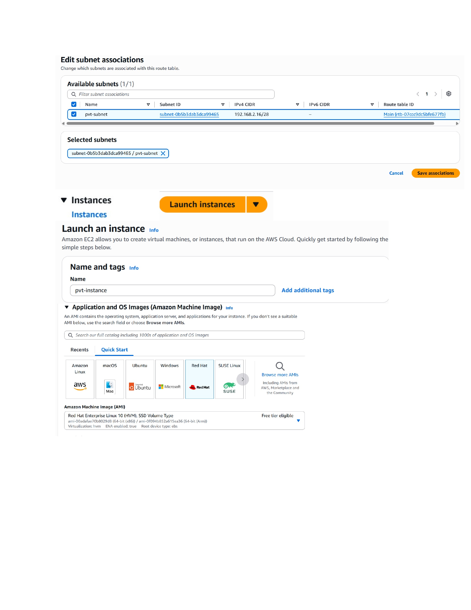
What I did: Associated the private subnet with the private route table and started configuring the private RHEL EC2 instance.

Select RHEL Instance Type
Topic: Select RHEL Instance Type
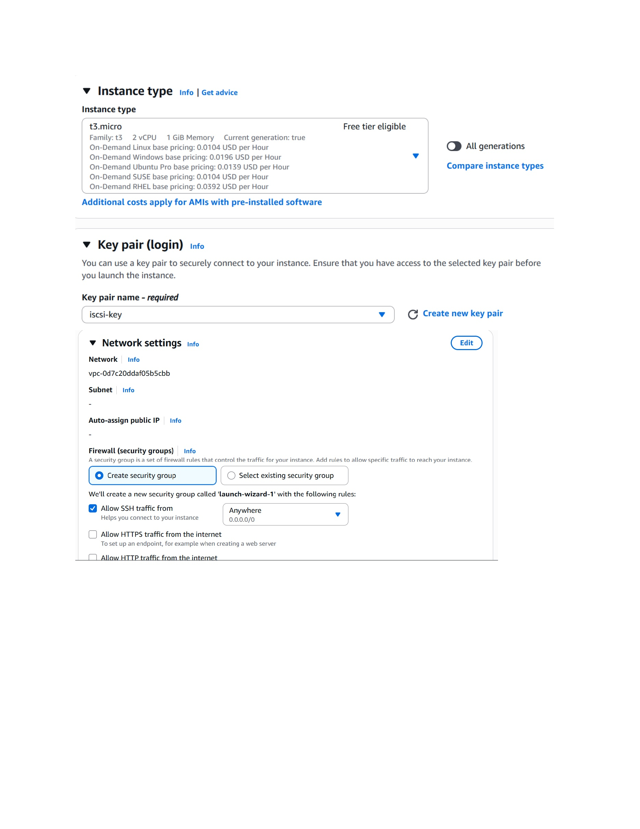
What I did: Selected the t3.micro instance type and prepared the key-pair configuration for the RHEL instance.

Configure Private Instance Network
Topic: Configure Private Instance Network
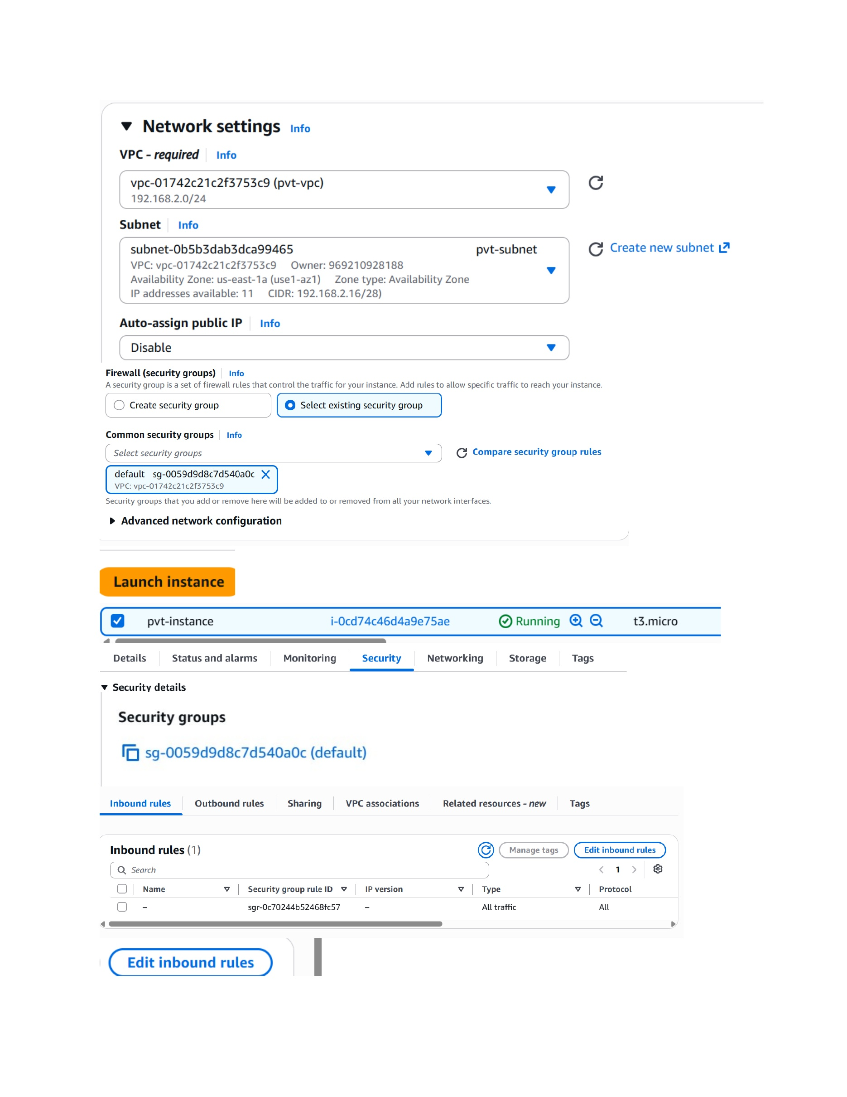
What I did: Selected the private VPC and private subnet and disabled public IP assignment for the RHEL instance.

Configure Private Instance Security Group
Topic: Configure Private Instance Security Group
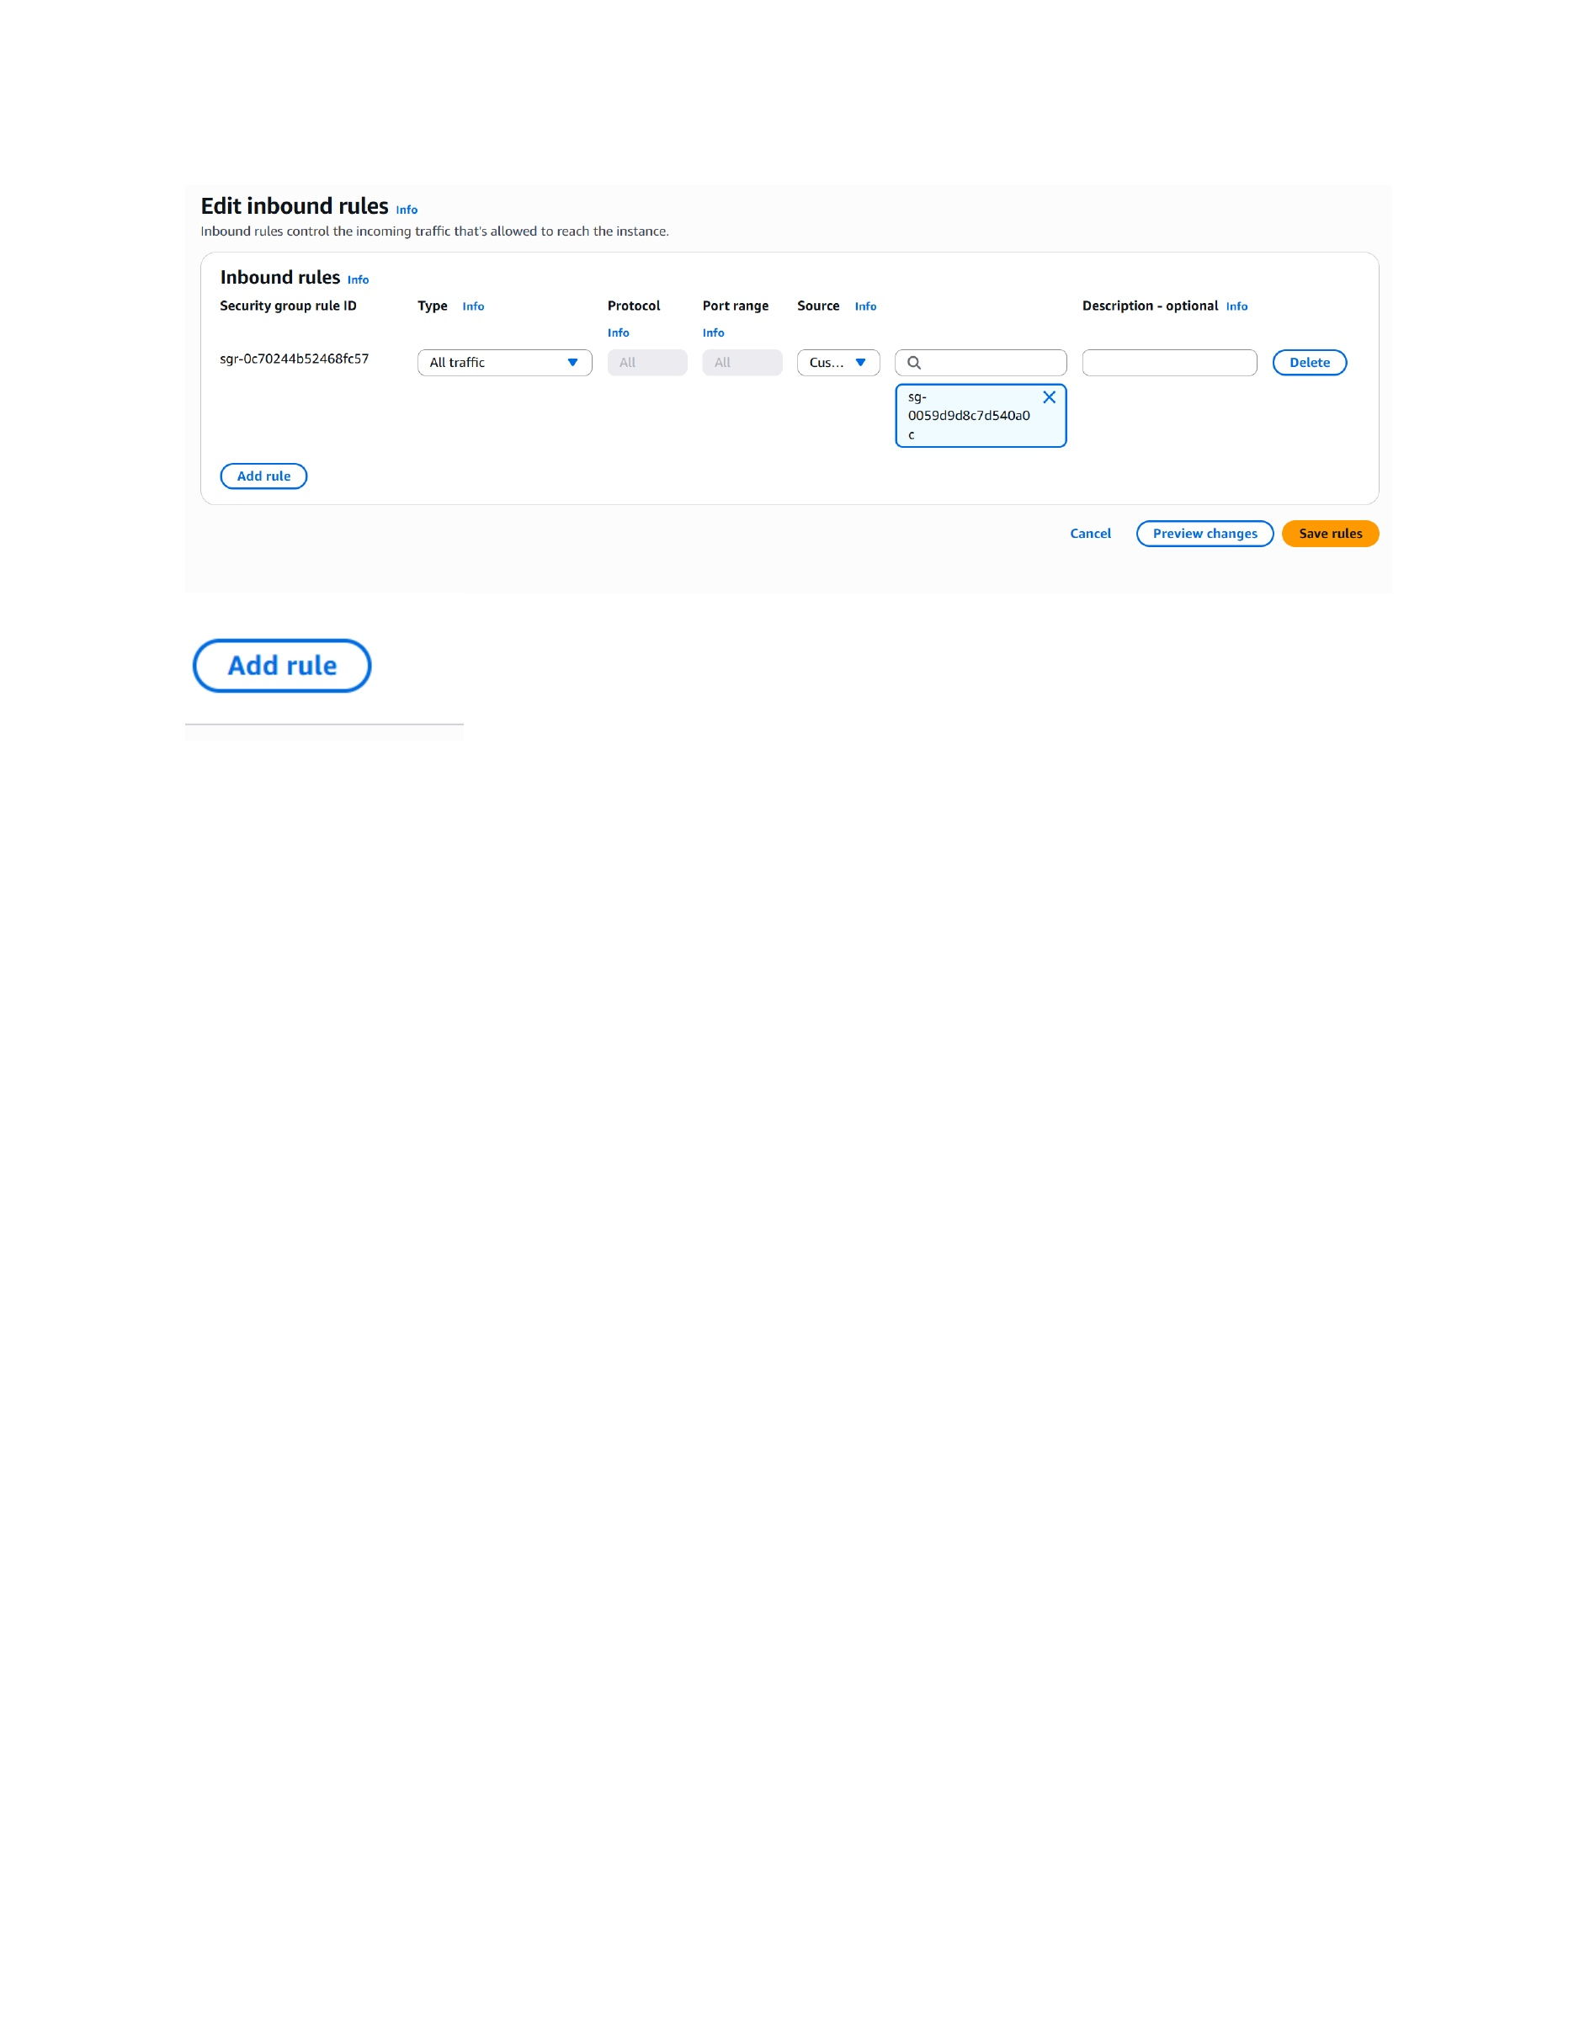
What I did: Configured the inbound security-group rules for the private RHEL instance.

